# Microsoft ADC Cybersecurity Skilling Program

# Week 7 Assignment 13 LAB

**Student Name:** DEBORAH BINYANYA NYATICHI

**Student ID:** ADC-CSS02-25051

## Introduction

In this lab, we explore the configuration and functionality of Azure Firewall, a cloud-native and intelligent network security service that protects Azure Virtual Network resources. This lab is designed as part of the AZ-500: Microsoft Azure Security Technologies course, and it focuses on equipping learners with hands-on experience in deploying and managing Azure Firewall to control both inbound and outbound traffic through defined rules and routing.Throughout the lab, we will deploy a pre-configured environment using an ARM template, then proceed to set up an Azure Firewall to enforce security controls. Key tasks include creating default routes, configuring application and network rules, specifying custom DNS settings, and validating the firewall's effectiveness through comprehensive testing. These tasks demonstrate how Azure Firewall integrates with other Azure services to provide centralized traffic inspection and threat intelligence-based filtering, which are essential in safeguarding cloud environments against modern security threats.This lab not only reinforces theoretical knowledge but also provides practical skills needed for securing Azure networks in real-world scenarios.

## Tasks Completed

### Required Lab Setup

Hello Deborah, on [SEA-Dev](https://labclient.labondemand.com/Instructions/84cc1d99-bbb8-44ef-a7f0-fc6990515d65) click [Ctrl+Alt+Delete](https://labclient.labondemand.com/Instructions/84cc1d99-bbb8-44ef-a7f0-fc6990515d65) to activate the Ctrl + Alt + Delete sequence and bring up the logon page.

*Any links like the one above will send Ctrl+Alt+Delete to the selected machine. This can also be done the****Commands****menu (lightning bolt) in the upper-left hand corner of the screen.*

Sign in as Admin with the password Pa55w.rd.

**Download the Lab Files**

*This will copy the latest lab files from GitHub and configure the directories as needed for the remainder of the lab exercises. You will see a 'Success!' message above, once the process is complete.*

Once you have received the 'Success!' message, click **Next** to proceed to the lab.

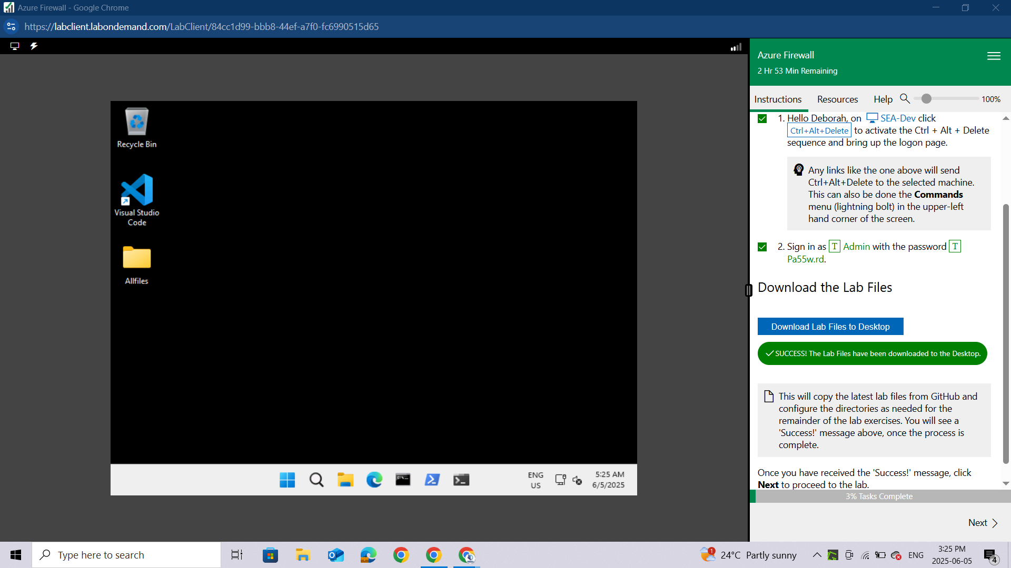

### Lab 03: Azure Firewall

**Student lab manual**

**Lab scenario**

You have been asked to install Azure Firewall. This will help your organization control inbound and outbound network access which is an important part of an overall network security plan. Specifically, you would like to create and test the following infrastructure components:

* A virtual network with a workload subnet and a jump host subnet.
* A virtual machine is each subnet.
* A custom route that ensures all outbound workload traffic from the workload subnet must use the firewall.
* Firewall Application rules that only allow outbound traffic to www.bing.com.
* Firewall Network rules that allow external DNS server lookups.

For all the resources in this lab, we are using the **East US** region. Verify with your instructor this is the region to use for class.

### Lab objectives

In this lab, you will complete the following exercise:

* Exercise 1: Deploy and test an Azure Firewall

**Azure Firewall diagram**

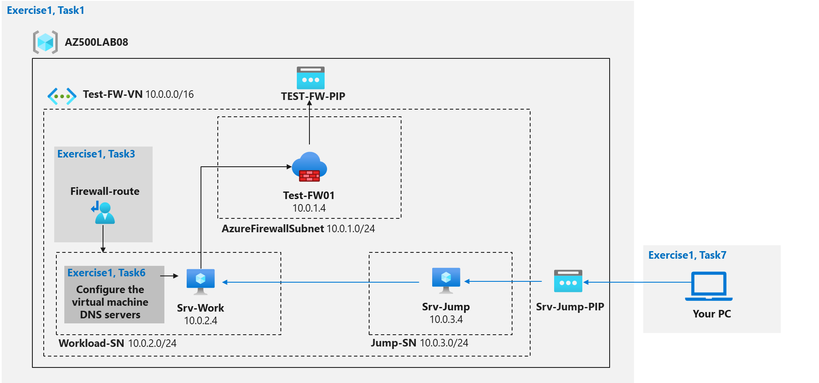

### Instructions

**Lab files:**

* ***\Allfiles\Labs\08\template.json***

### Exercise 1: Deploy and test an Azure Firewall

Estimated timing: 40 minutes

In this exercise, you will complete the following tasks:

* Task 1: Use a template to deploy the lab environment.
* Task 2: Deploy an Azure firewall.
* Task 3: Create a default route.
* Task 4: Configure an application rule.
* Task 5: Configure a network rule.
* Task 6: Configure DNS servers.
* Task 7: Test the firewall.

### Task 1: Use a template to deploy the lab environment.

In this task, you will review and deploy the lab environment.

In this task, you will create a virtual machine by using an ARM template. This virtual machine will be used in the last exercise for this lab.

Sign-in to the Azure portal [**https://portal.azure.com/**](https://portal.azure.com/)

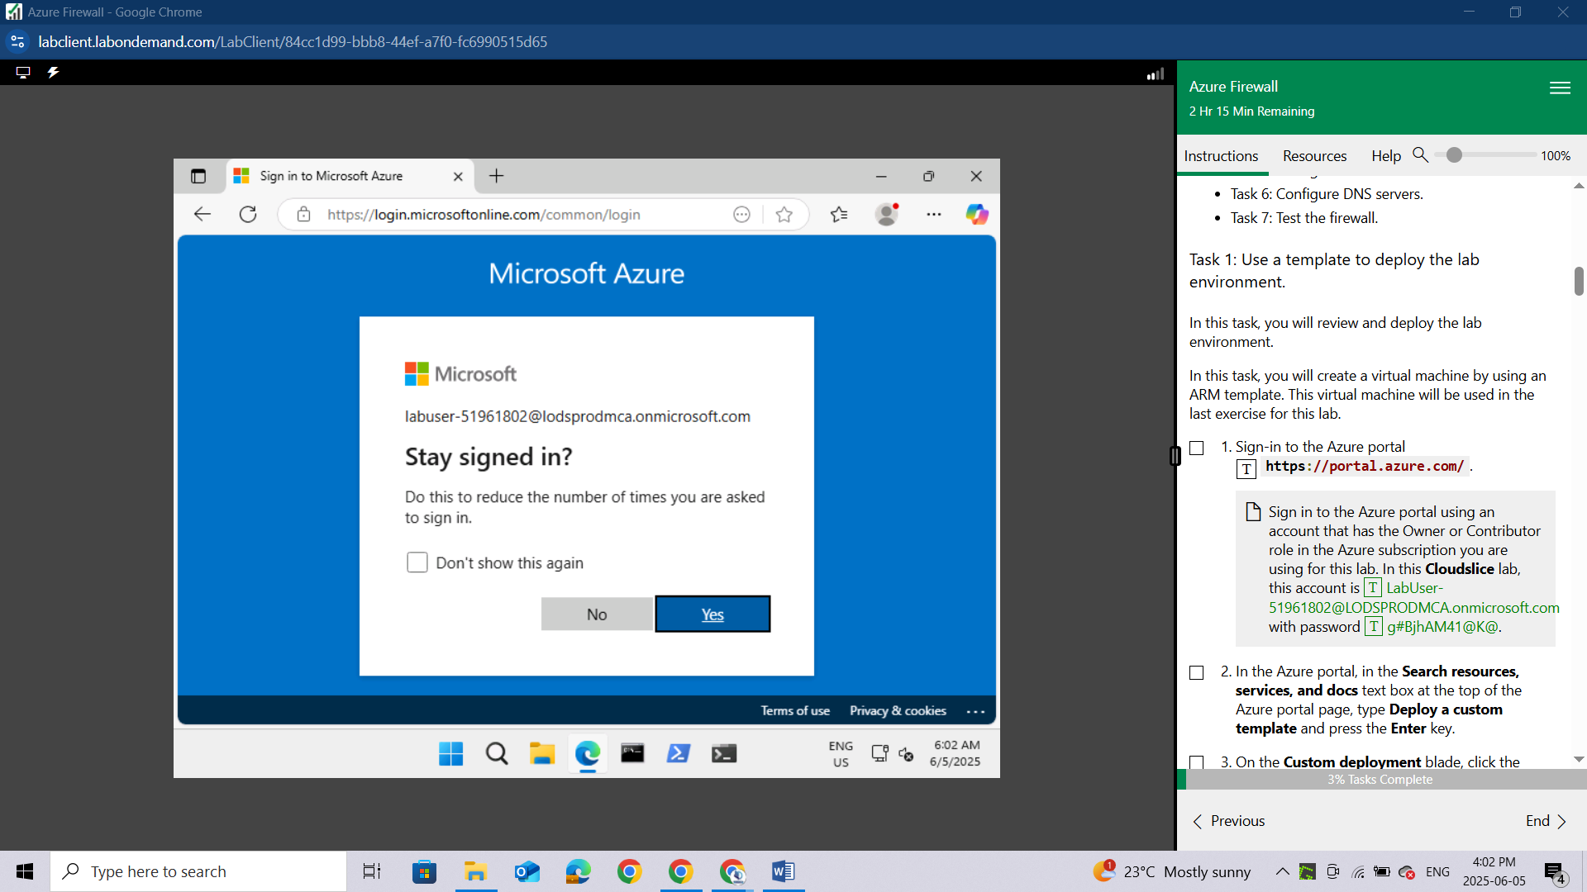

In the Azure portal, in the **Search resources, services, and docs** text box at the top of the Azure portal page, type **Deploy a custom template** and press the **Enter** key.

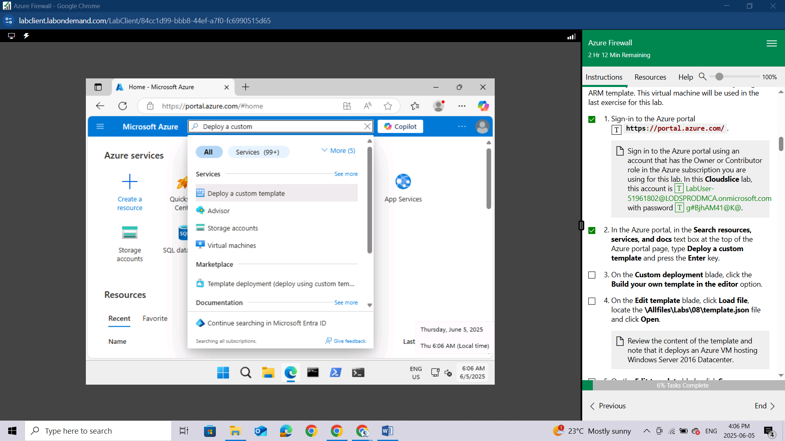

On the **Custom deployment** blade, click the **Build your own template in the editor** option.

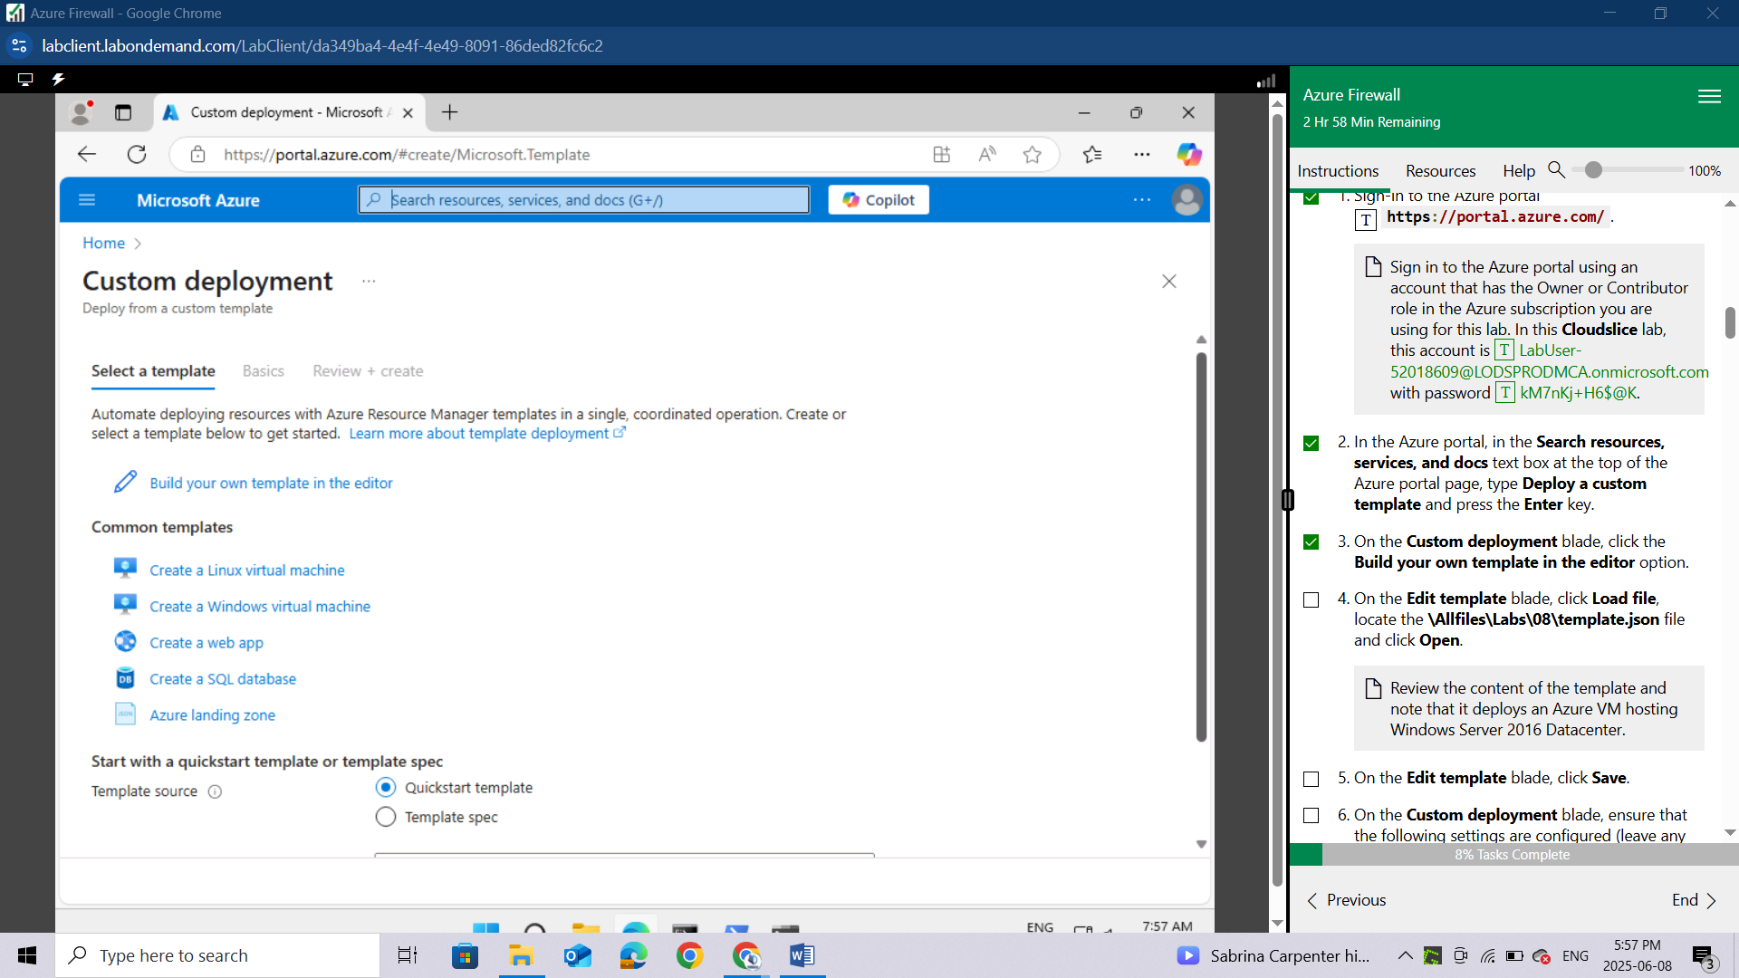

On the **Edit template** blade, click **Load file**, locate the **\Allfiles\Labs\08\template.json** file and click **Open**.

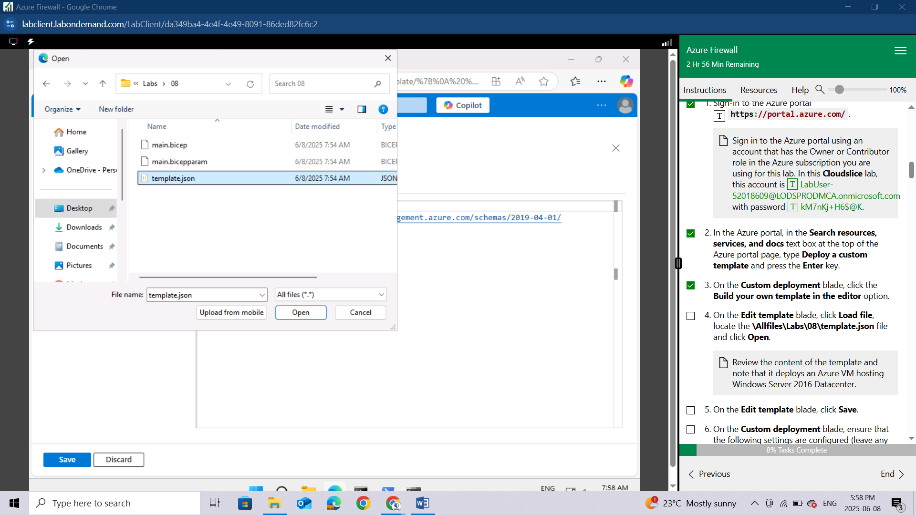

*Review the content of the template and note that it deploys an Azure VM hosting Windows Server 2016 Datacenter.*

On the **Edit template** blade, click **Save**.

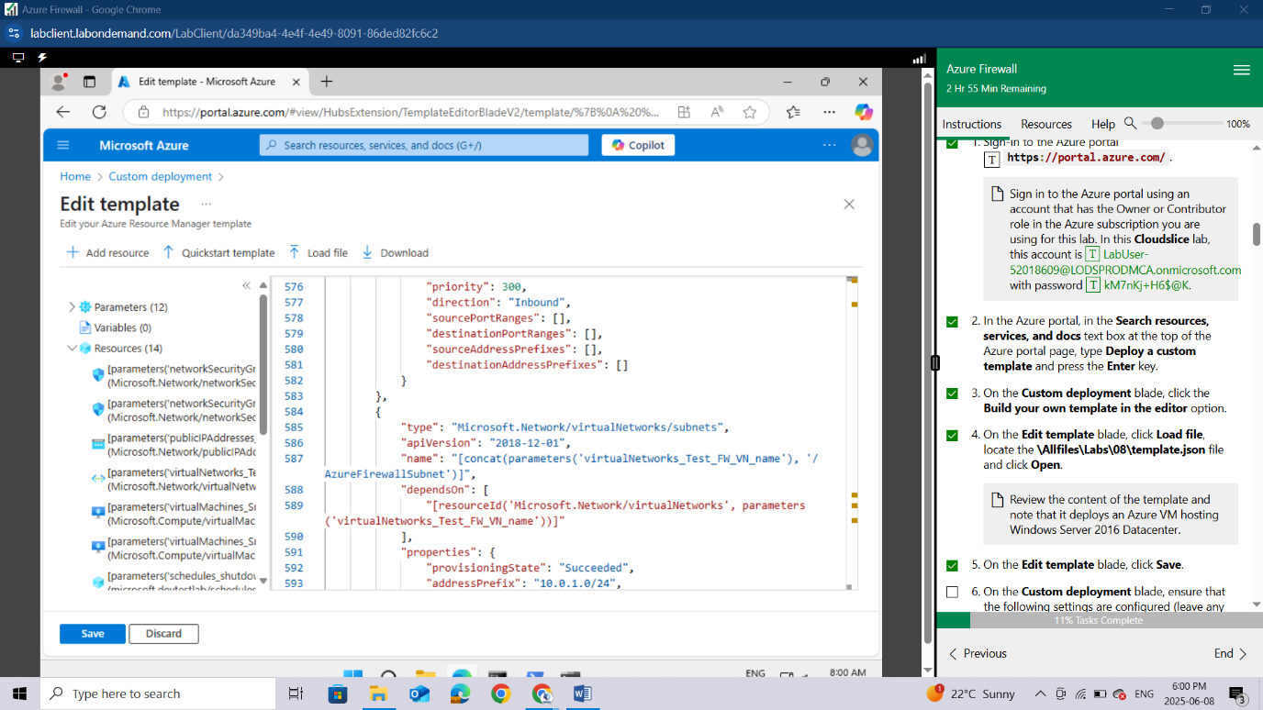

On the **Custom deployment** blade, ensure that the following settings are configured (leave any others with their default values):

| **Setting** | **Value** |
| --- | --- |
| Subscription | the name of the Azure subscription you will be using in this lab |
| Resource group | Use existing Resource Group **AZ500LAB08** |
| Location | **(US) East US** |
| adminPassword | A secure password of your own choosing for the virtual machines. Remember the password. You will need it later to connect to the VMs. |

*To identify Azure regions where you can provision Azure VMs, refer to*[*https://azure.microsoft.com/en-us/regions/offers/*](https://azure.microsoft.com/en-us/regions/offers/)

Click **Review + create**, and then click **Create**.

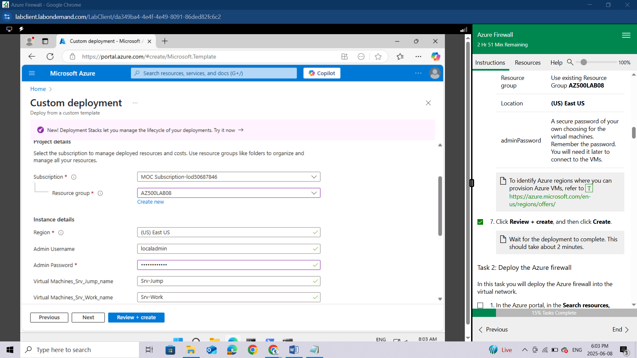

*Wait for the deployment to complete. This should take about 2 minutes.*

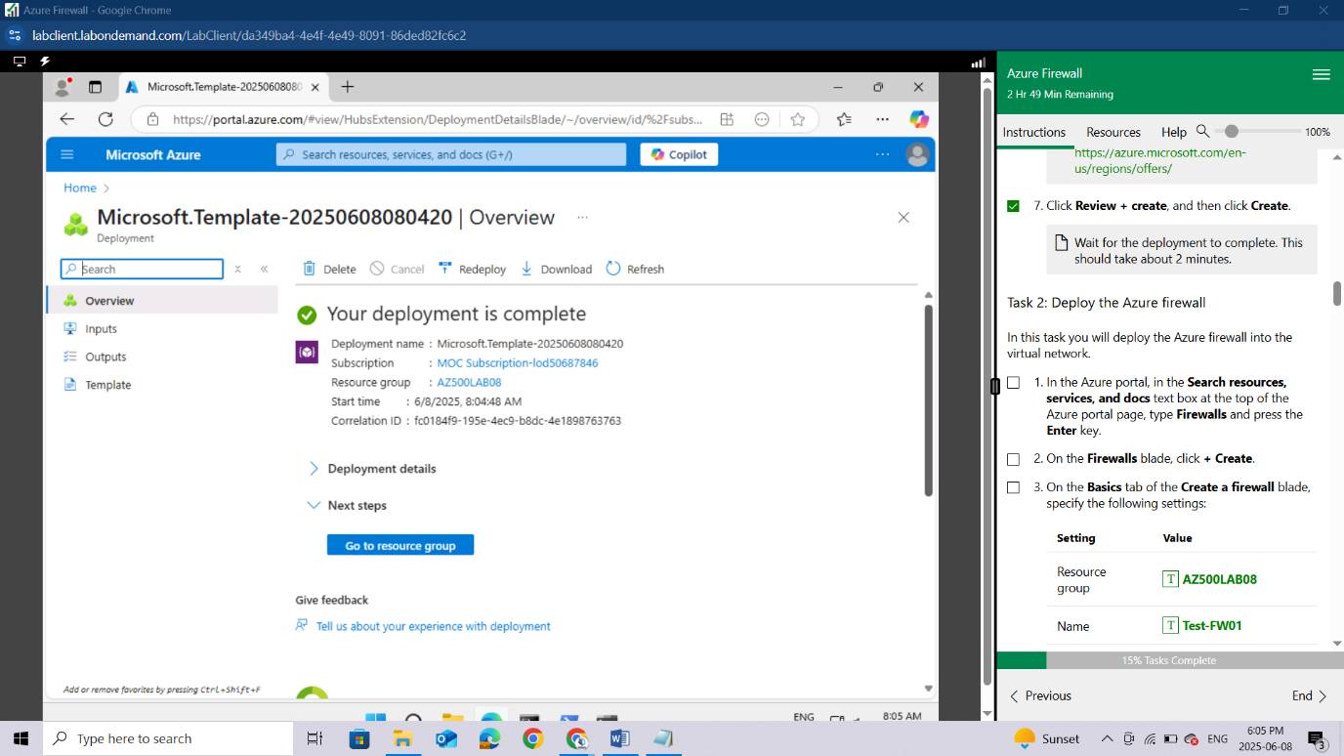

### Task 2: Deploy the Azure firewall

In this task you will deploy the Azure firewall into the virtual network.

In the Azure portal, in the **Search resources, services, and docs** text box at the top of the Azure portal page, type **Firewalls** and press the **Enter** key.

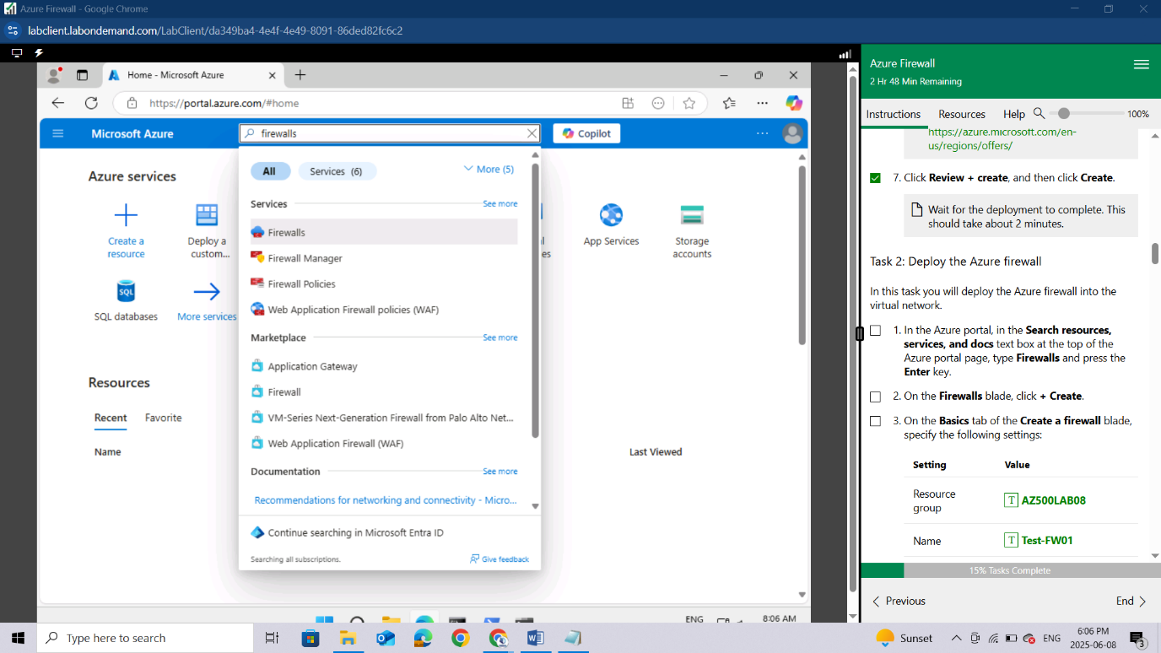

On the **Firewalls** blade, click **+ Create**.

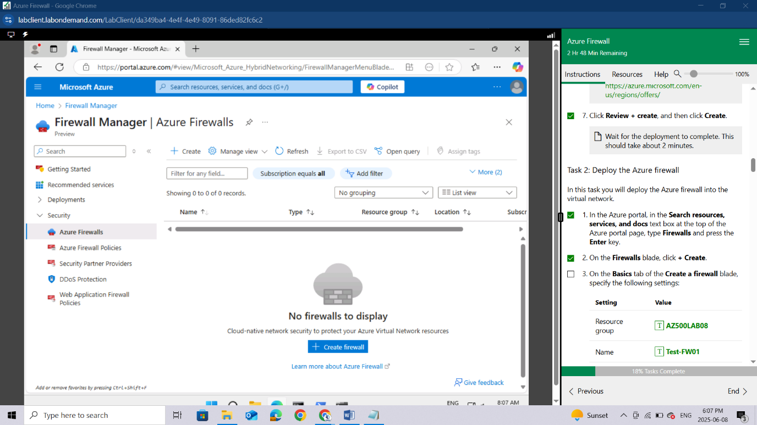

On the **Basics** tab of the **Create a firewall** blade, specify the following settings:

| **Setting** | **Value** |
| --- | --- |
| Resource group | **AZ500LAB08** |
| Name | **Test-FW01** |
| Region | **(US) East US** |
| Firewall SKU | **Standard** |
| Firewall management | **Use Firewall rules (classic) to manage this firewall** |
| Choose a virtual network | click the **Use existing** option and, in the drop-down list, select **Test-FW-VN** |
| Firewall Management NIC | To disable this feature, **deselect** the **Enable Firewall Management NIC** option. |
| Public IP address | clck **Add new** and type the name **TEST-FW-PIP** and click **OK** |

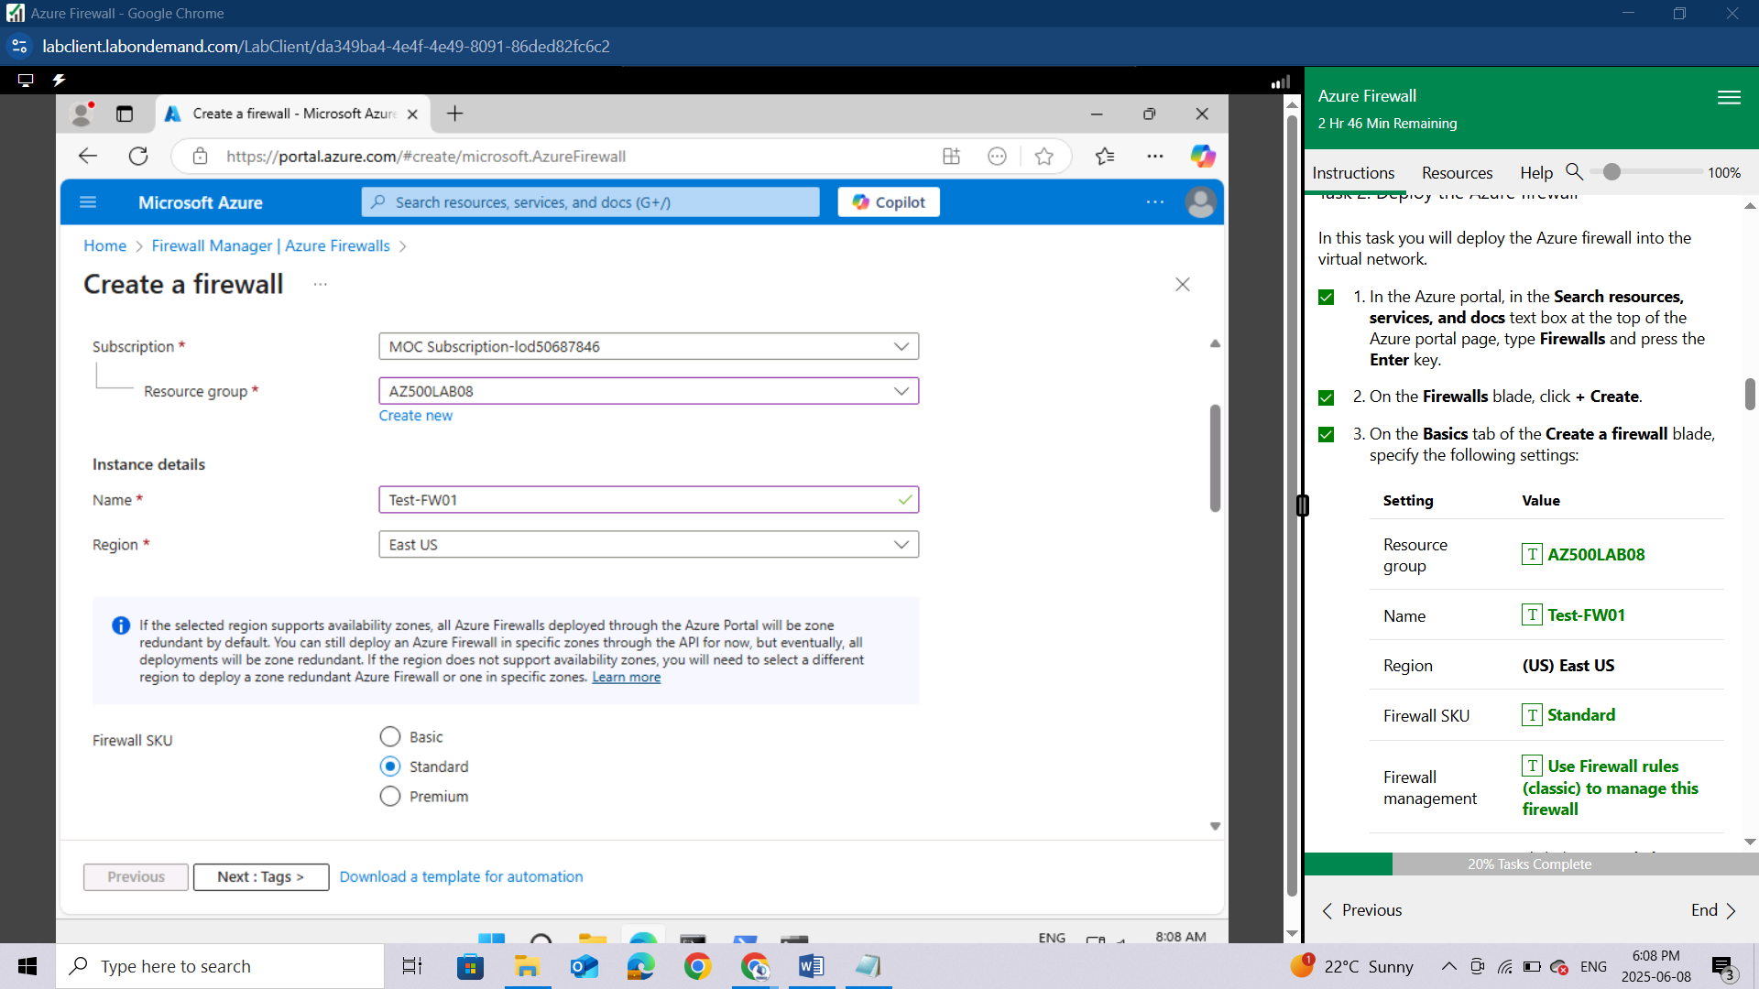

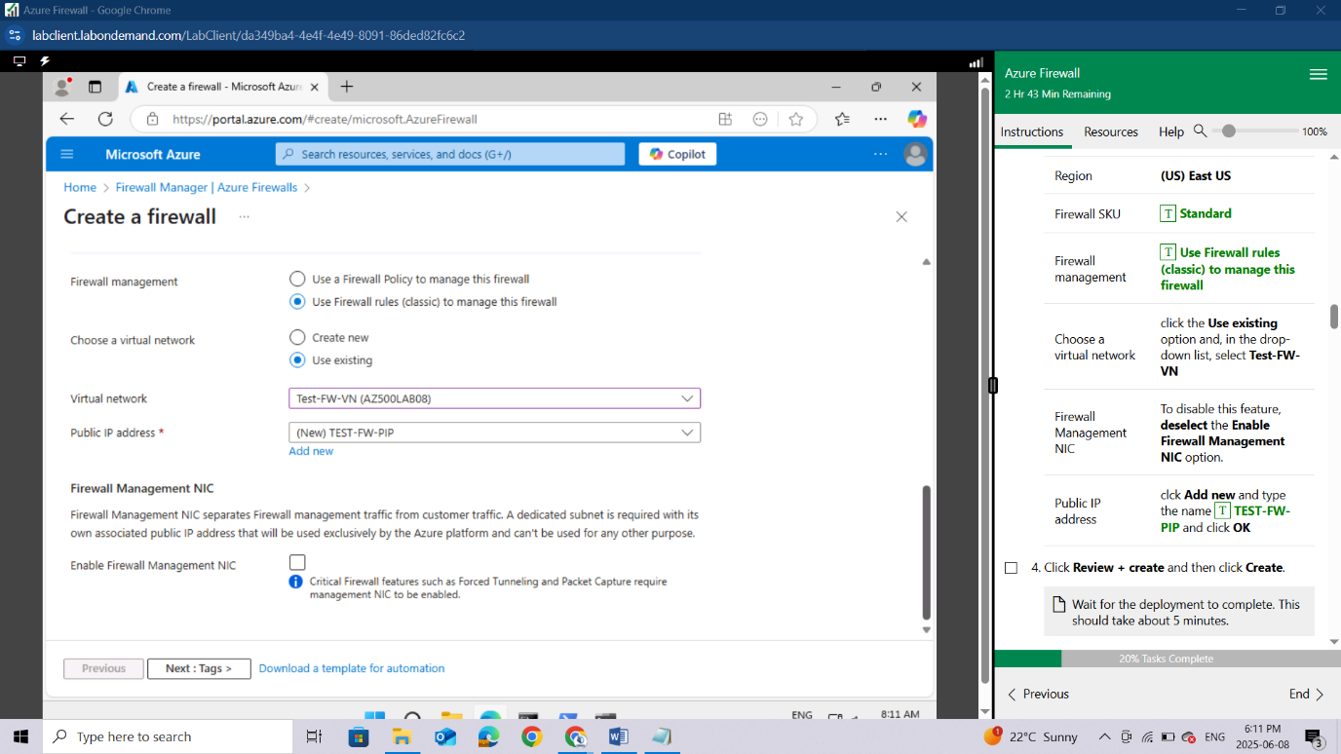

Click **Review + create** and then click **Create**.

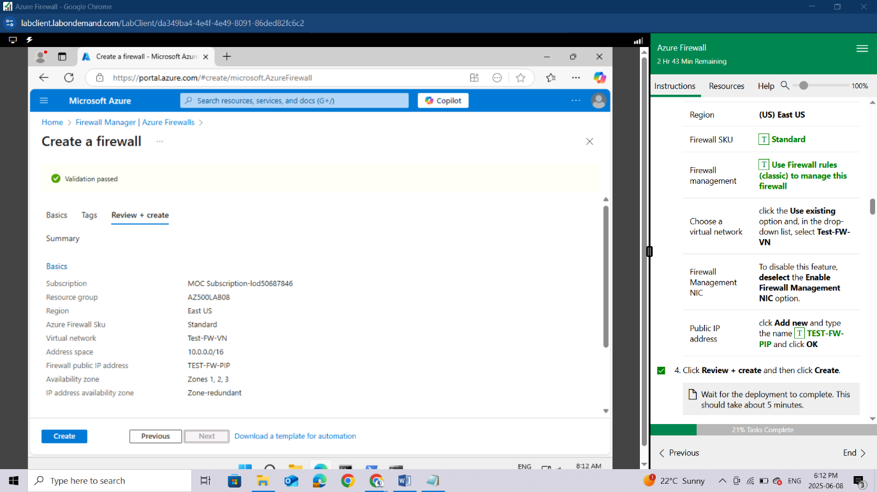

*Wait for the deployment to complete. This should take about 5 minutes.*

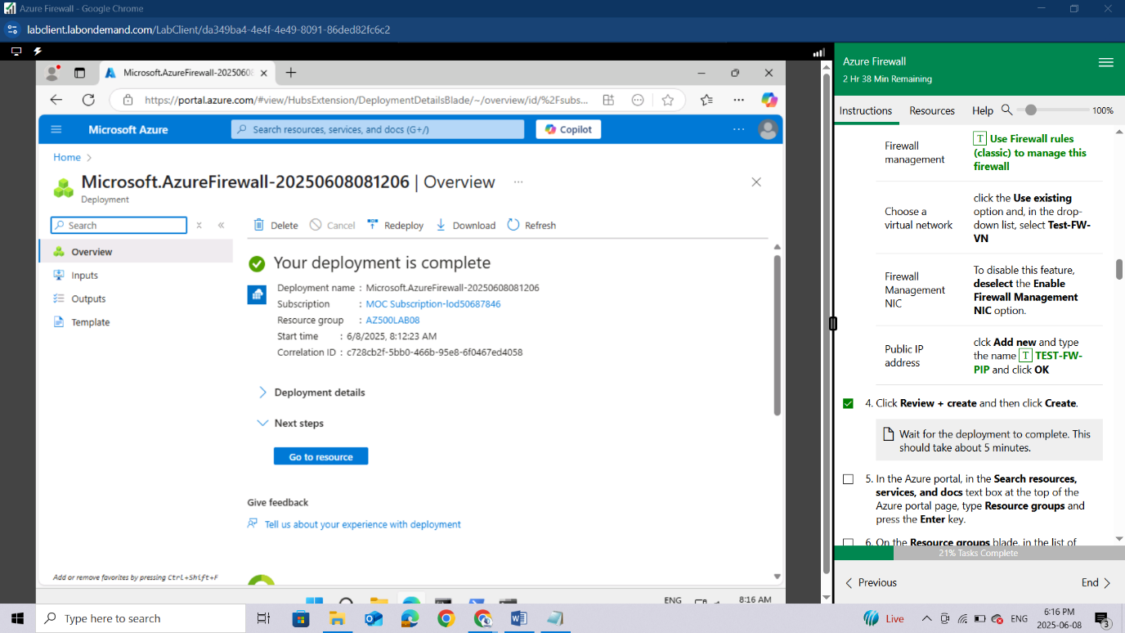

In the Azure portal, in the **Search resources, services, and docs** text box at the top of the Azure portal page, type **Resource groups** and press the **Enter** key.

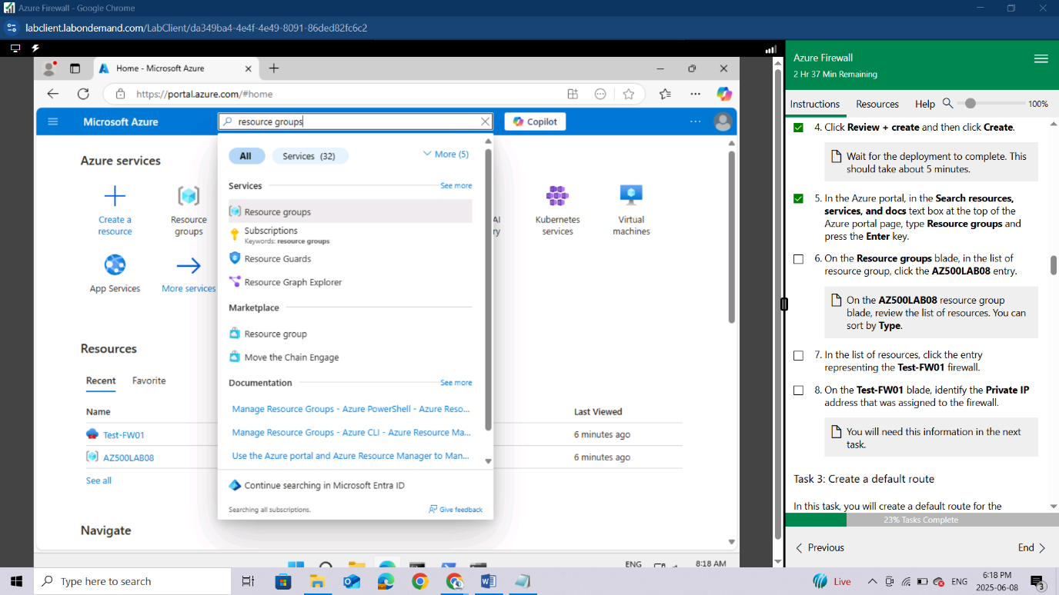

On the **Resource groups** blade, in the list of resource group, click the **AZ500LAB08** entry.

*On the****AZ500LAB08****resource group blade, review the list of resources. You can sort by****Type****.*

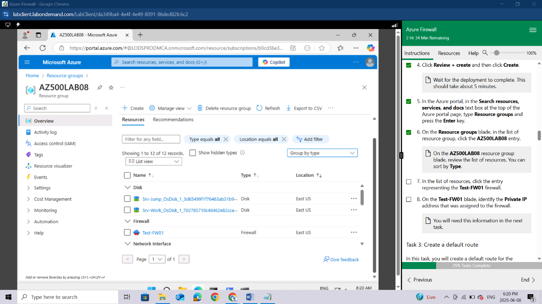

In the list of resources, click the entry representing the **Test-FW01** firewall.

On the **Test-FW01** blade, identify the **Private IP** address that was assigned to the firewall.

*You will need this information in the next task.*

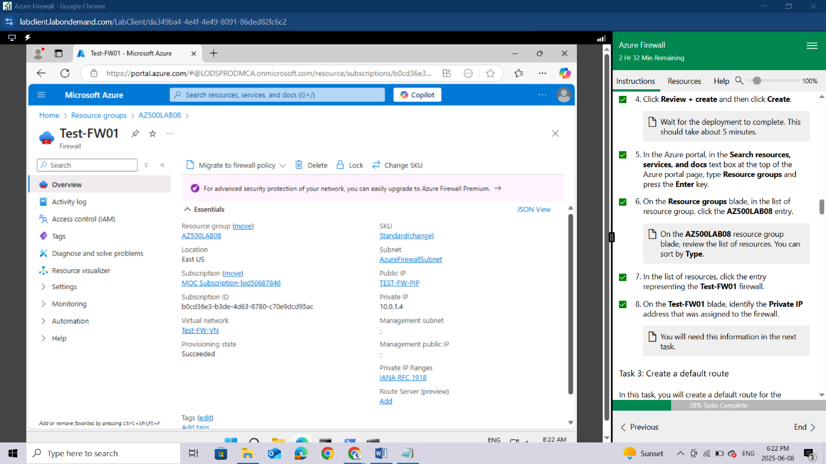

### Task 3: Create a default route

In this task, you will create a default route for the **Workload-SN** subnet. This route will configure outbound traffic through the firewall.

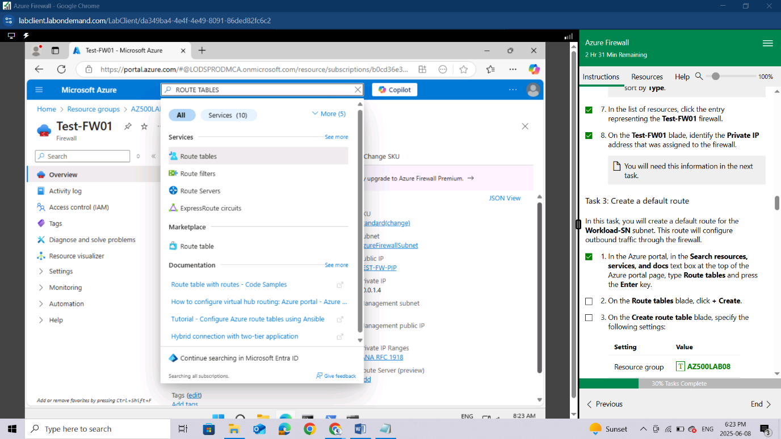

On the **Route tables** blade, click **+ Create**.

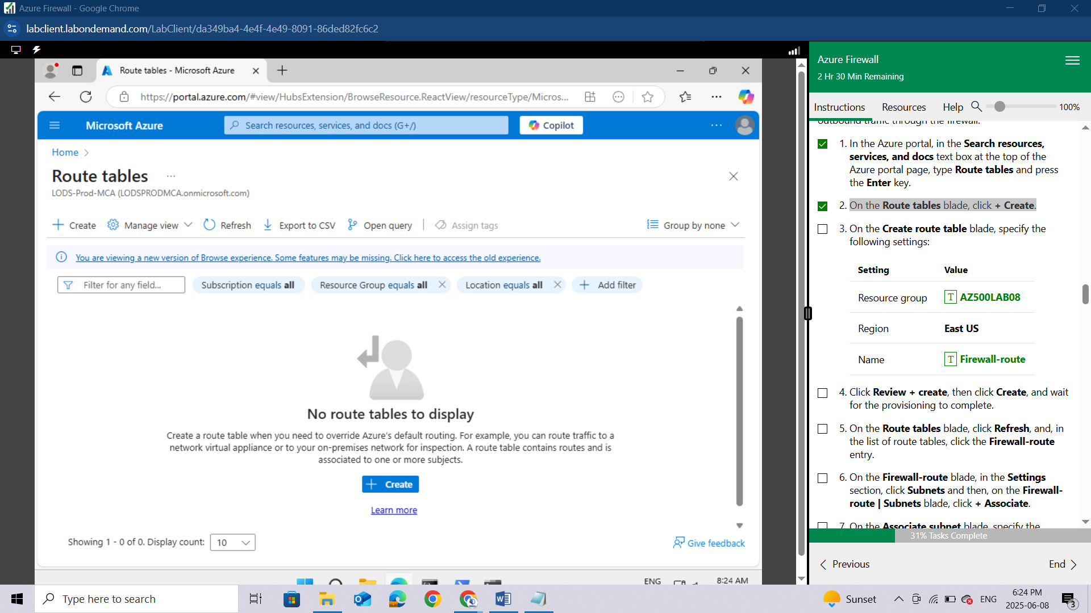

On the **Create route table** blade, specify the following settings:

| **Setting** | **Value** |
| --- | --- |
| Resource group | **AZ500LAB08** |
| Region | **East US** |
| Name | **Firewall-route** |

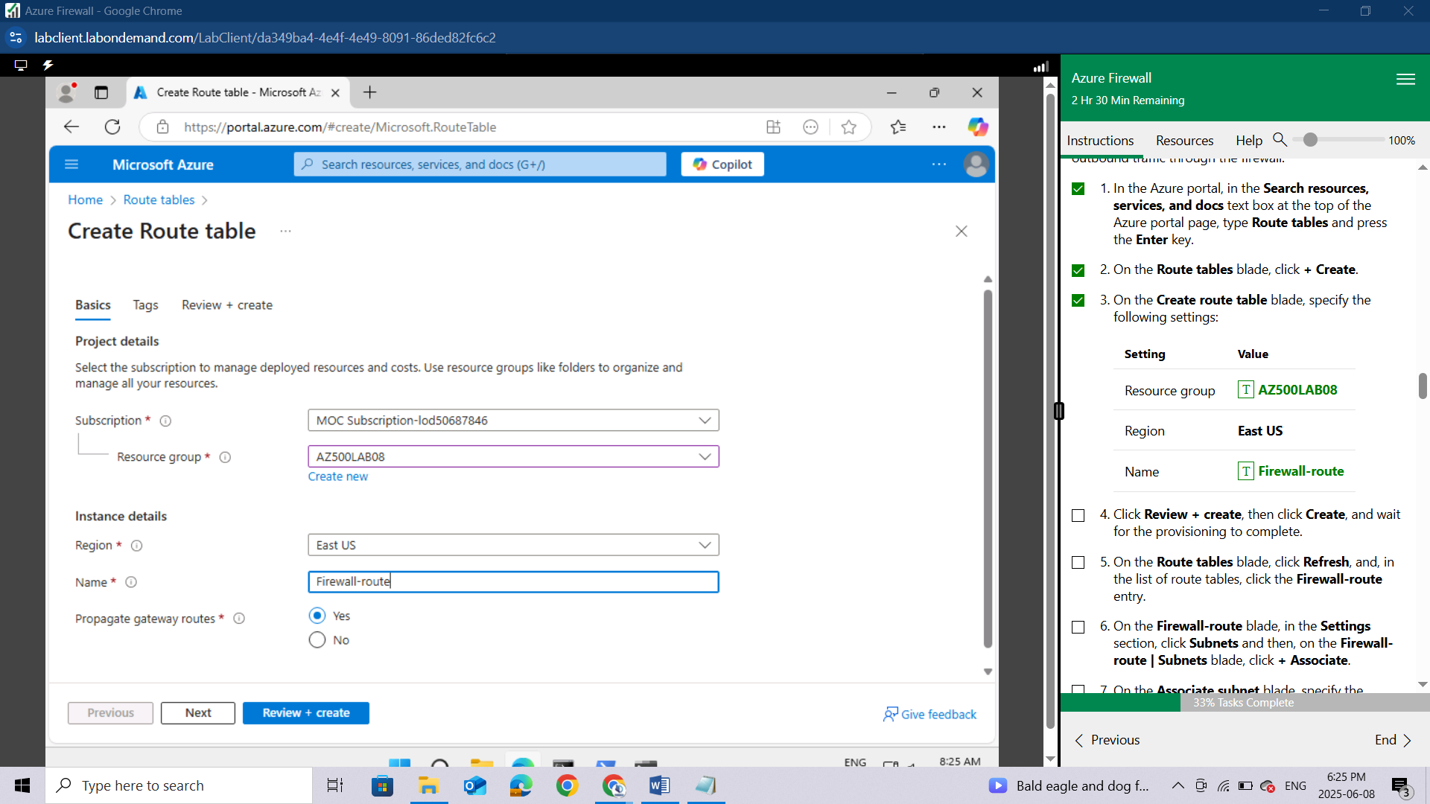

Click **Review + create**, then click **Create**, and wait for the provisioning to complete.

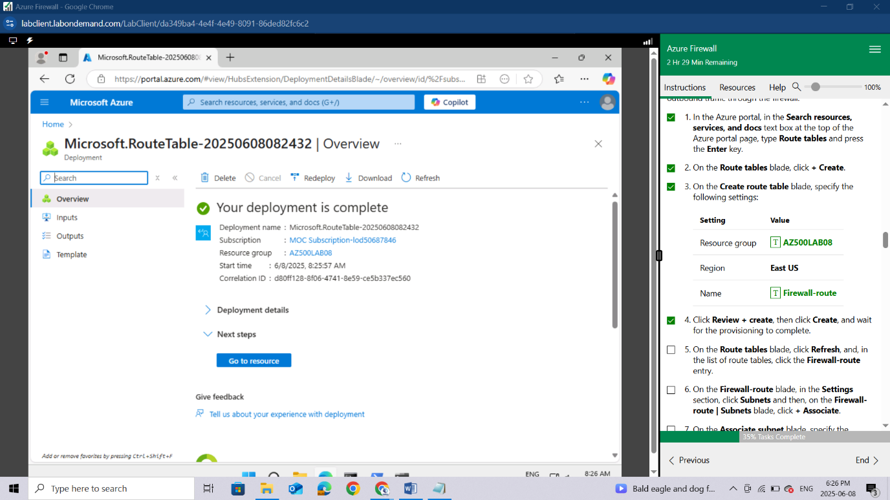

On the **Route tables** blade, click **Refresh**, and, in the list of route tables, click the **Firewall-route** entry.

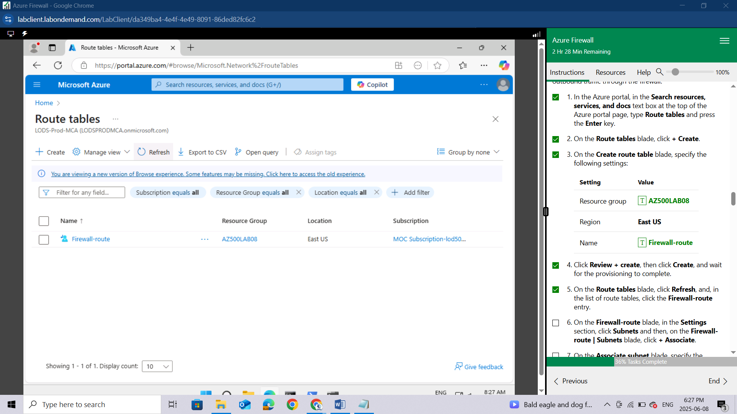

On the **Firewall-route** blade, in the **Settings** section, click **Subnets** and then, on the **Firewall-route | Subnets** blade, click **+ Associate**.

On the **Associate subnet** blade, specify the following settings:

| **Setting** | **Value** |
| --- | --- |
| Virtual network | **Test-FW-VN** |
| Subnet | **Workload-SN** |

*Ensure the****Workload-SN****subnet is selected for this route, otherwise the firewall won't work correctly.*

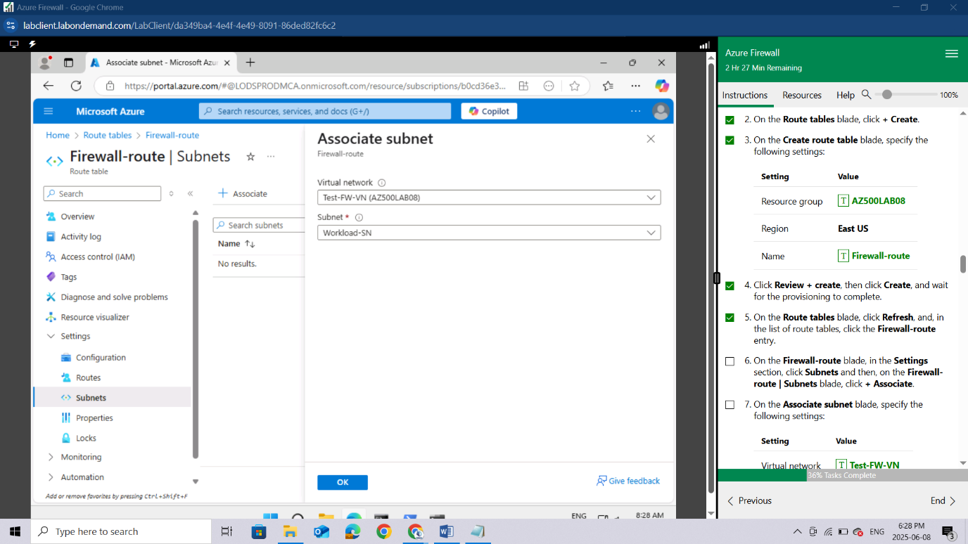

Click **OK** to associate the firewall to the virtual network subnet.

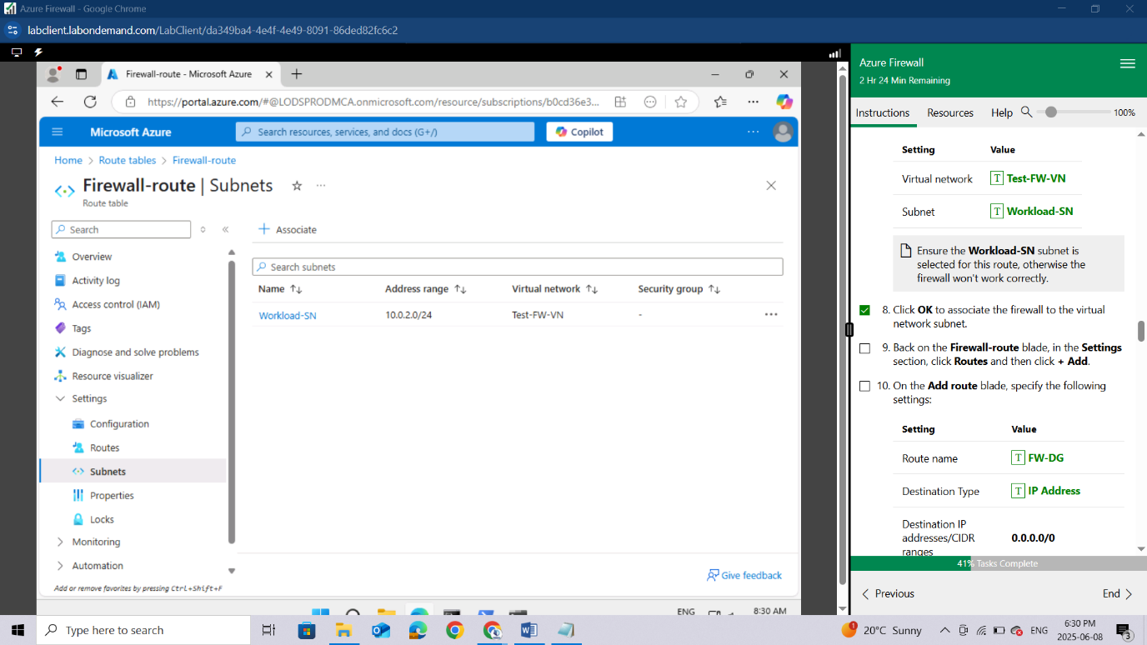

Back on the **Firewall-route** blade, in the **Settings** section, click **Routes** and then click **+ Add**.

On the **Add route** blade, specify the following settings:

| **Setting** | **Value** |
| --- | --- |
| Route name | **FW-DG** |
| Destination Type | **IP Address** |
| Destination IP addresses/CIDR ranges | **0.0.0.0/0** |
| Next hop type | **Virtual appliance** |
| Next hop address | the private IP address of the firewall that you identified in the previous task |

*Azure Firewall is actually a managed service, but virtual appliance works in this situation.*

Click **Add** to add the route.

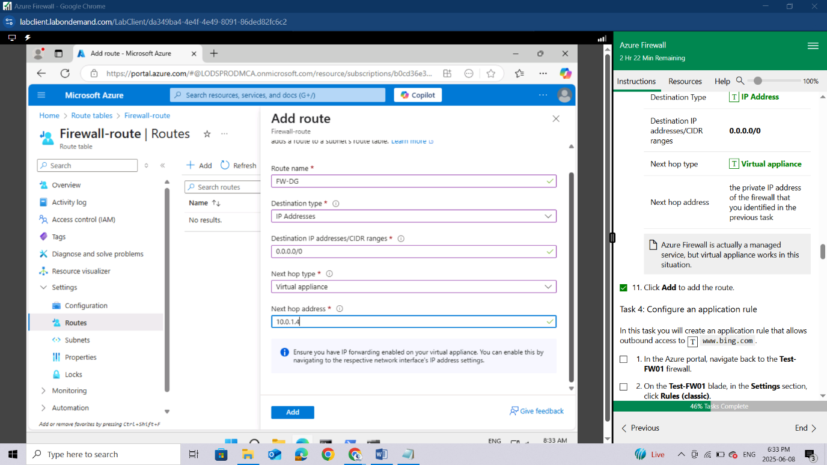

### Task 4: Configure an application rule

In this task you will create an application rule that allows outbound access to [www.bing.com](http://www.bing.com).

In the Azure portal, navigate back to the **Test-FW01** firewall.

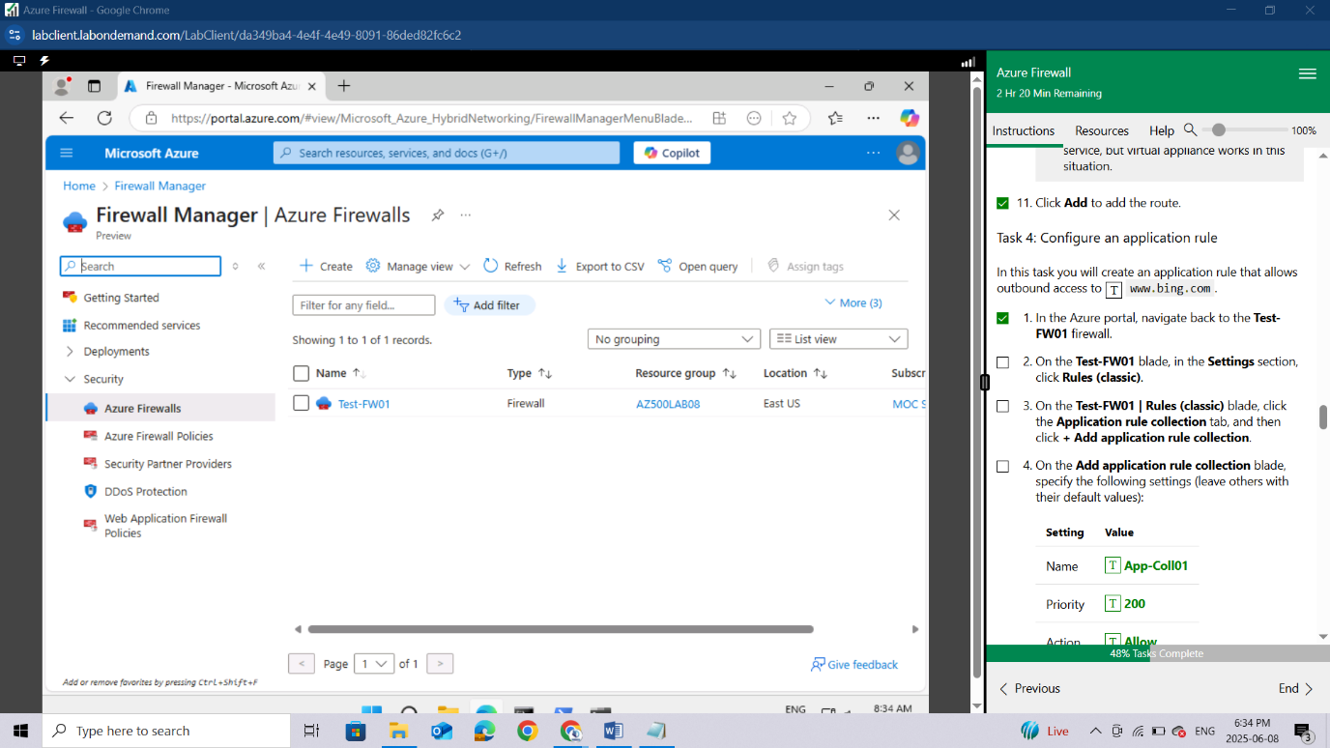

On the **Test-FW01** blade, in the **Settings** section, click **Rules (classic)**.

On the **Test-FW01 | Rules (classic)** blade, click the **Application rule collection** tab, and then click **+ Add application rule collection**.

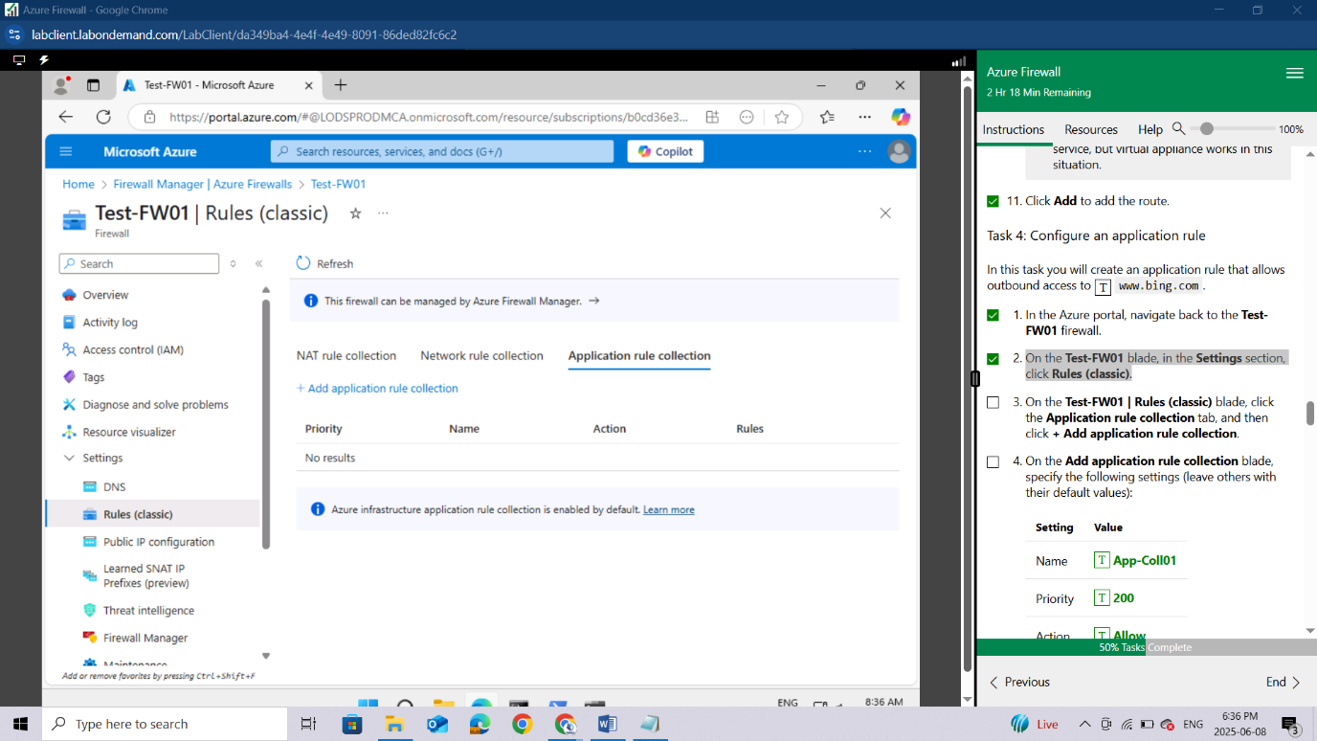

On the **Add application rule collection** blade, specify the following settings (leave others with their default values):

| **Setting** | **Value** |
| --- | --- |
| Name | **App-Coll01** |
| Priority | **200** |
| Action | **Allow** |

On the **Add application rule collection** blade, create a new entry in the **Target FQDNs** section with the following settings (leave others with their default values):

| **Setting** | **Value** |
| --- | --- |
| name | **AllowGH** |
| Source type | **IP Address** |
| Source | **10.0.2.0/24** |
| Protocol port | **http:80, https:443** |
| Target FQDNS | **www.bing.com** |

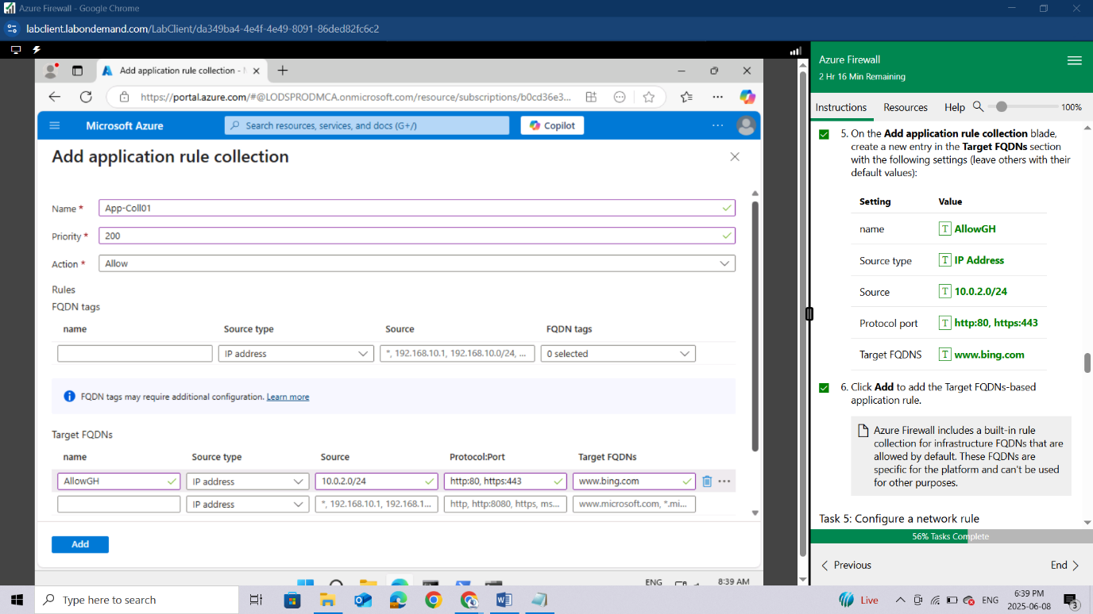

Click **Add** to add the Target FQDNs-based application rule.

*Azure Firewall includes a built-in rule collection for infrastructure FQDNs that are allowed by default. These FQDNs are specific for the platform and can't be used for other purposes.*

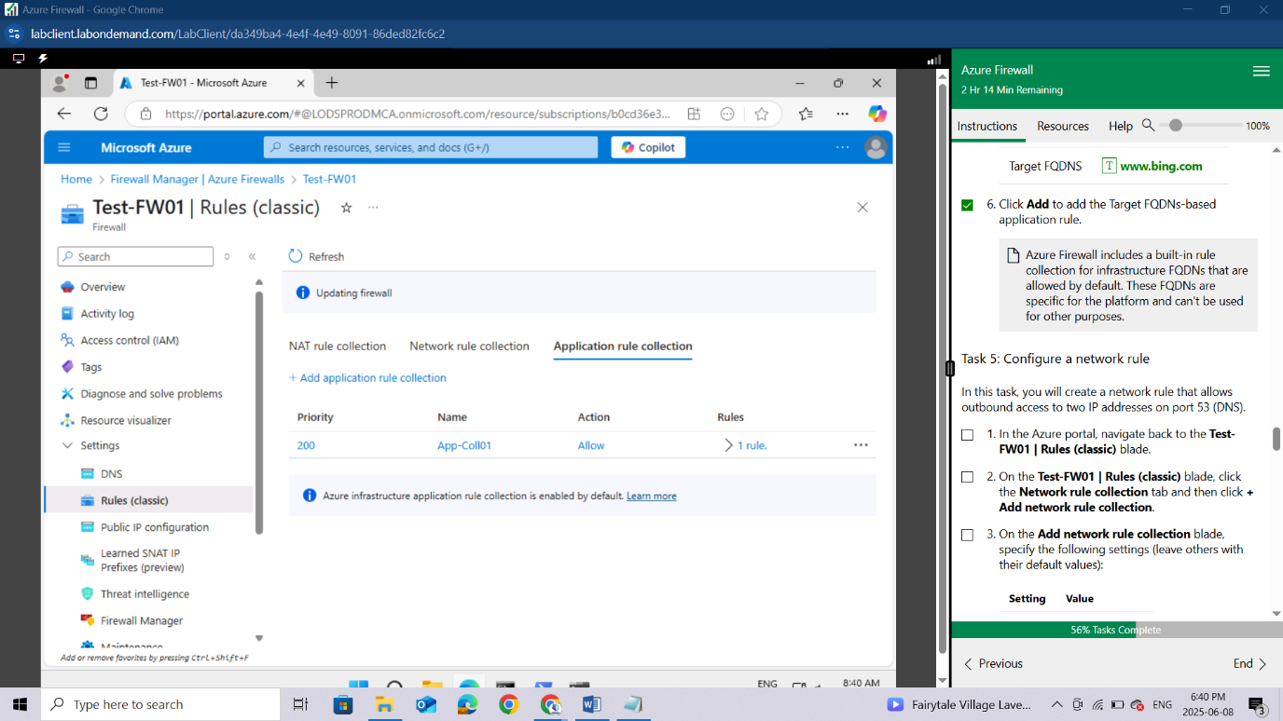

### Task 5: Configure a network rule

In this task, you will create a network rule that allows outbound access to two IP addresses on port 53 (DNS).

In the Azure portal, navigate back to the **Test-FW01 | Rules (classic)** blade.

On the **Test-FW01 | Rules (classic)** blade, click the **Network rule collection** tab and then click **+ Add network rule collection**.

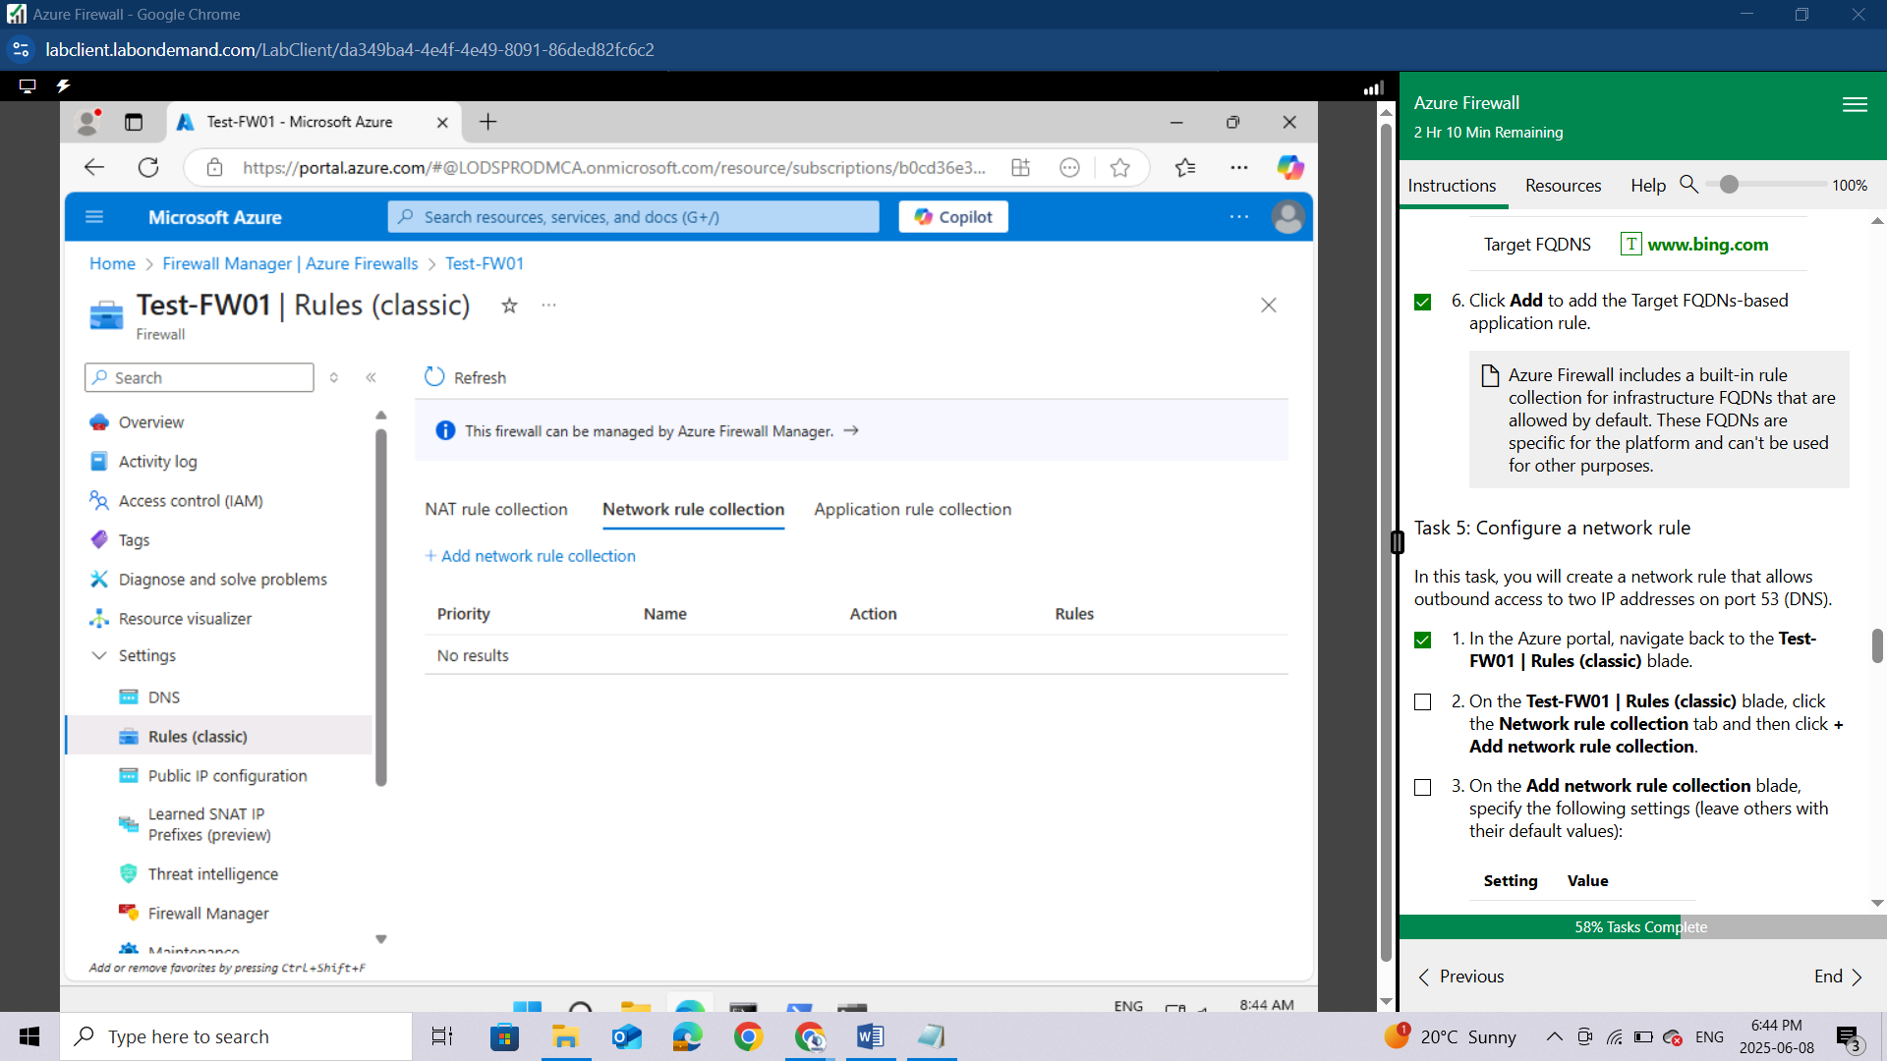

On the **Add network rule collection** blade, specify the following settings (leave others with their default values):

| **Setting** | **Value** |
| --- | --- |
| Name | **Net-Coll01** |
| Priority | **200** |
| Action | **Allow** |

On the **Add network rule collection** blade, create a new entry in the **IP Addresses** section with the following settings (leave others with their default values):

| **Setting** | **Value** |
| --- | --- |
| Name | **AllowDNS** |
| Protocol | **UDP** |
| Source type | **IP address** |
| Source Addresses | **10.0.2.0/24** |
| Destination type | **IP address** |
| Destination Address | **209.244.0.3,209.244.0.4** |
| Destination Ports | **53** |

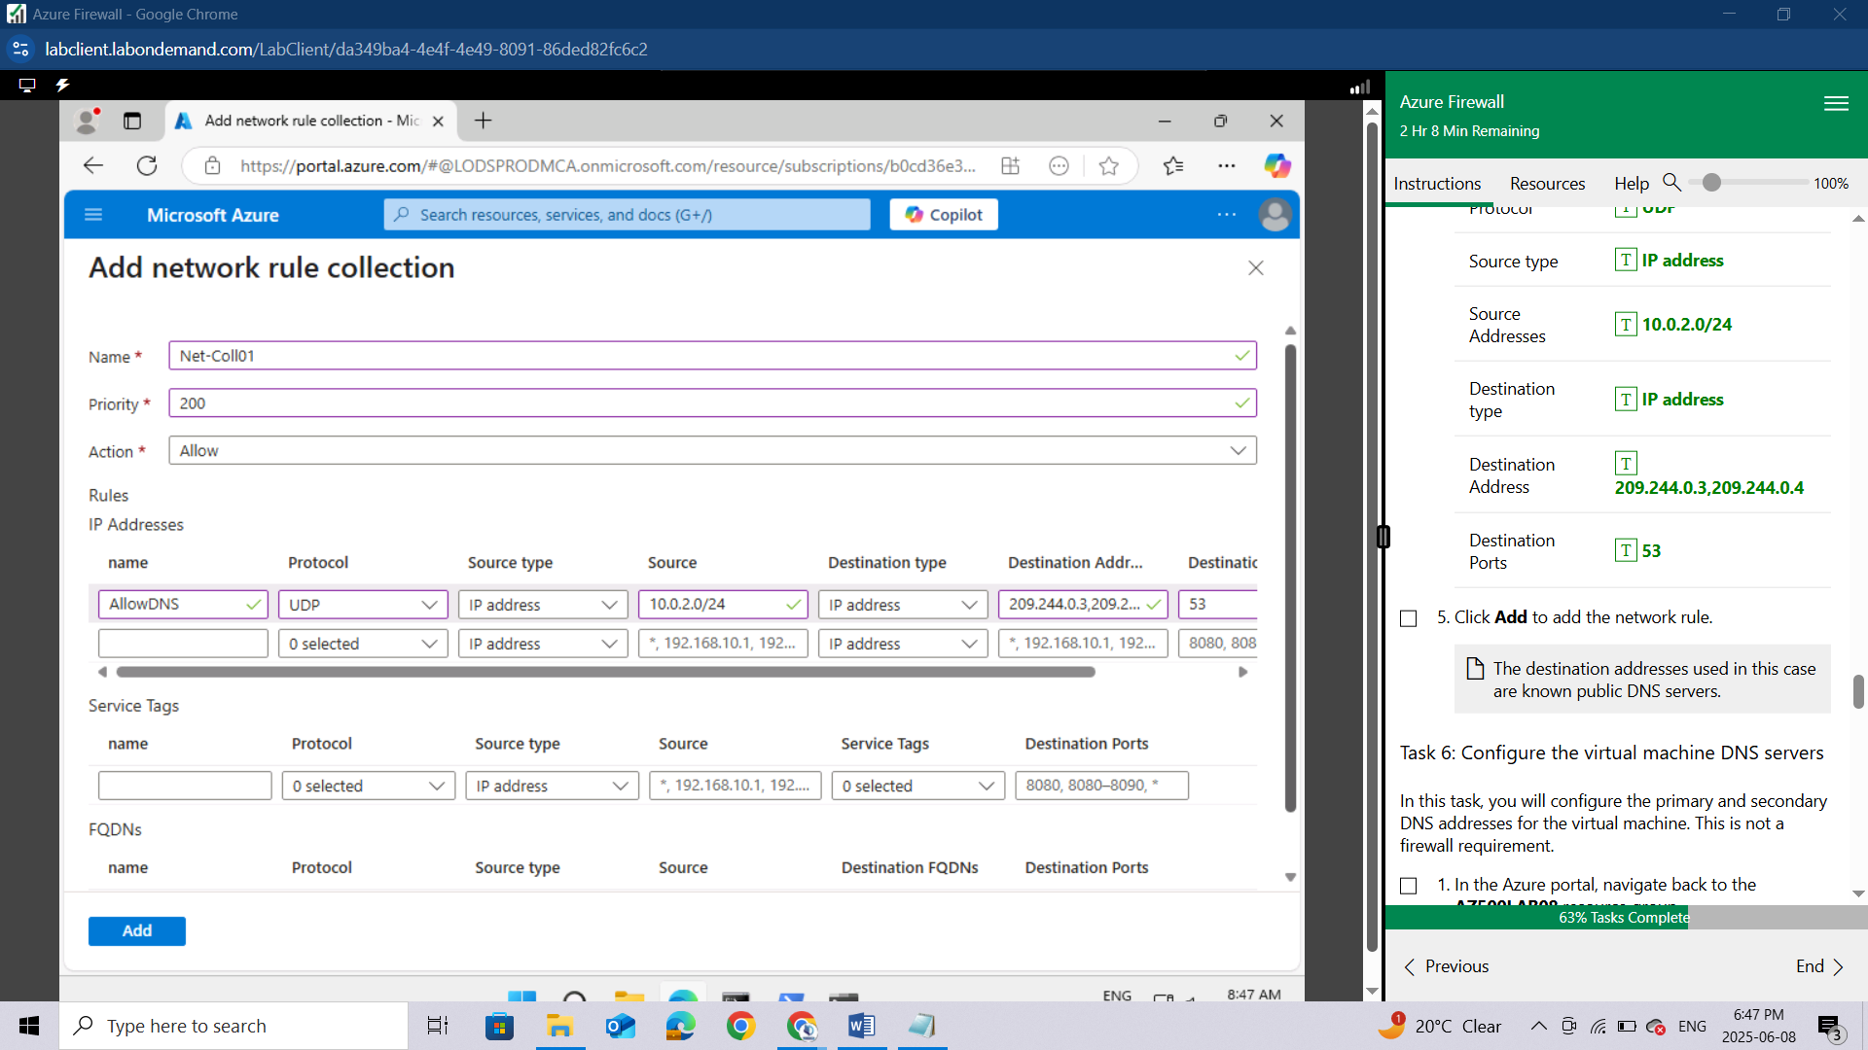

Click **Add** to add the network rule.

*The destination addresses used in this case are known public DNS servers.*

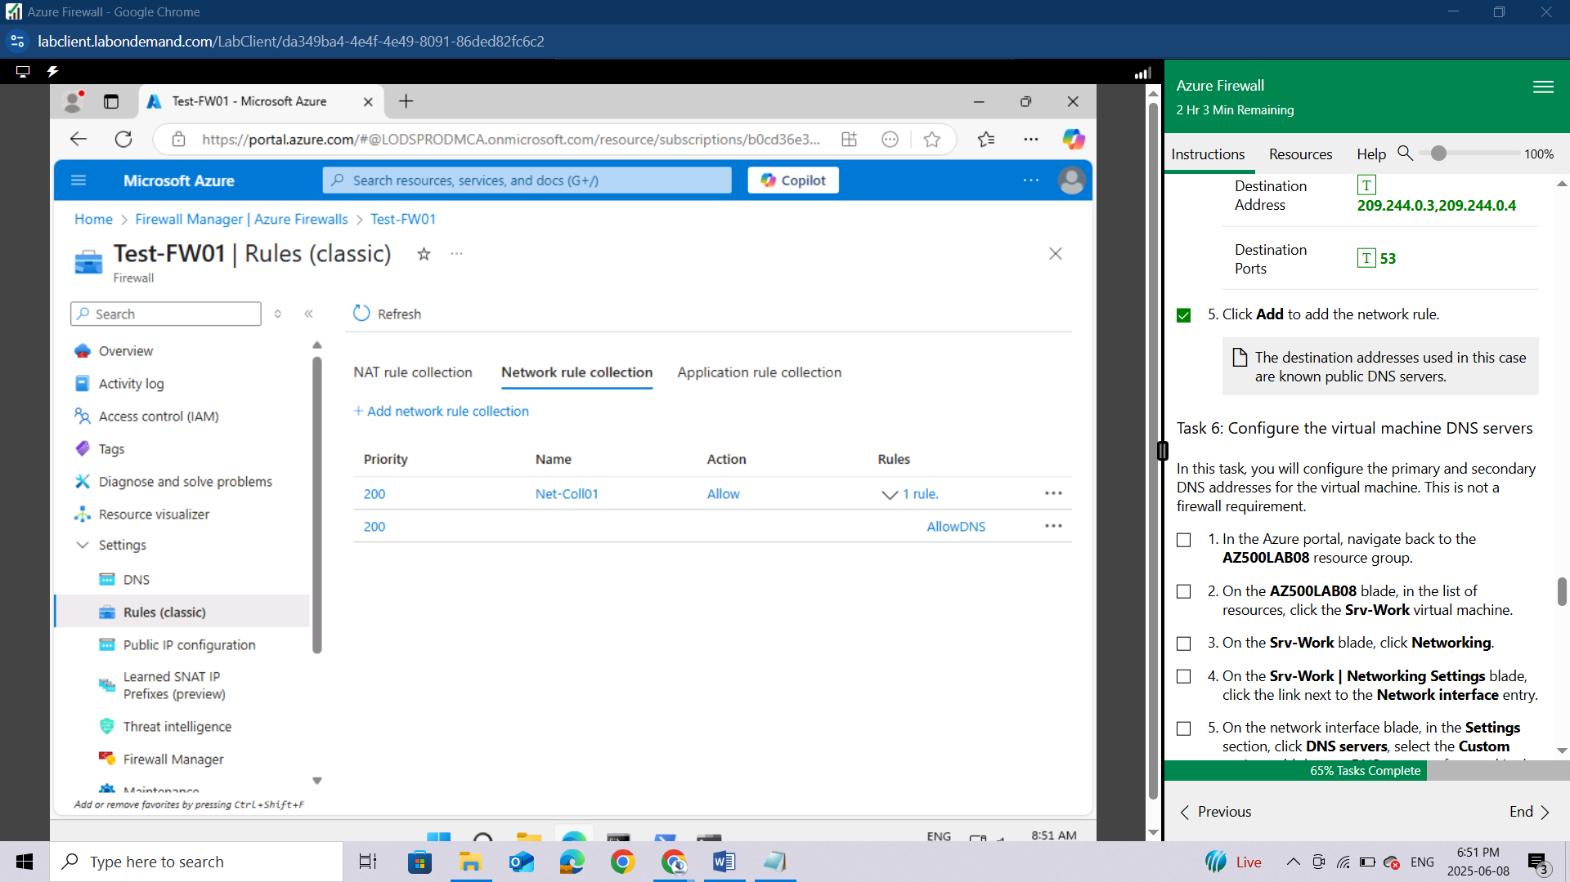

### Task 6: Configure the virtual machine DNS servers

In this task, you will configure the primary and secondary DNS addresses for the virtual machine. This is not a firewall requirement.

In the Azure portal, navigate back to the **AZ500LAB08** resource group.

On the **AZ500LAB08** blade, in the list of resources, click the **Srv-Work** virtual machine.

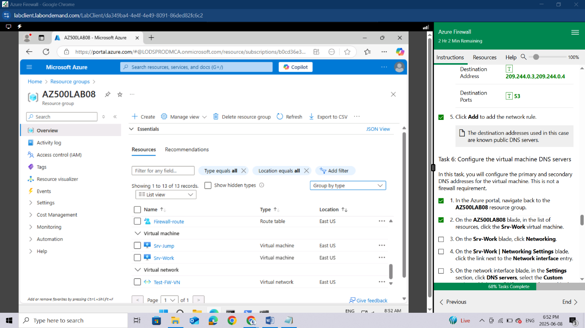

On the **Srv-Work** blade, click **Networking**.

On the **Srv-Work | Networking Settings** blade, click the link next to the **Network interface** entry.

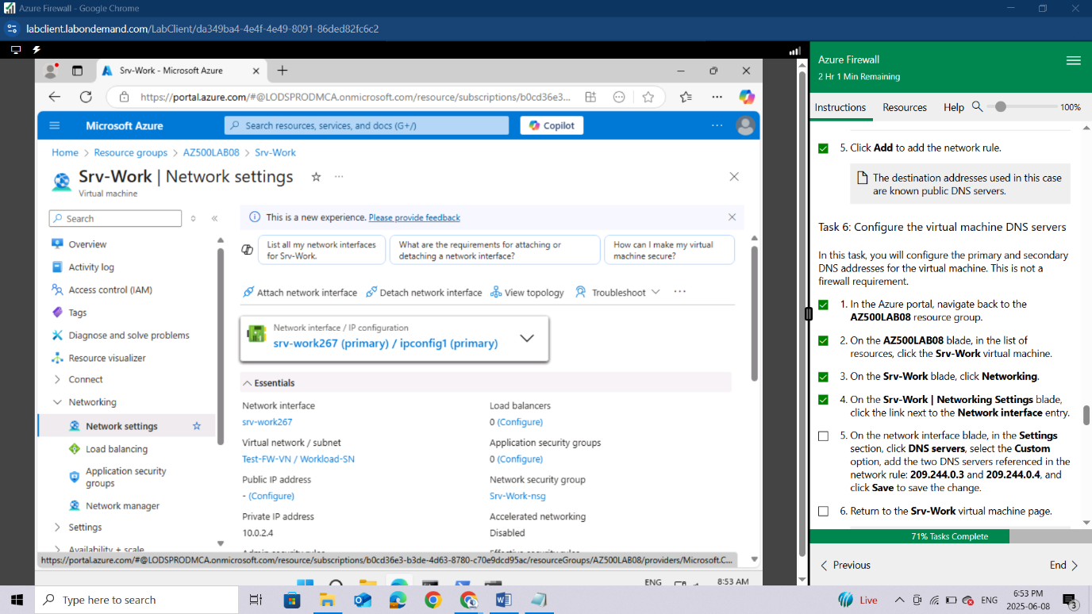

On the network interface blade, in the **Settings** section, click **DNS servers**, select the **Custom** option, add the two DNS servers referenced in the network rule: **209.244.0.3** and **209.244.0.4**, and click **Save** to save the change.

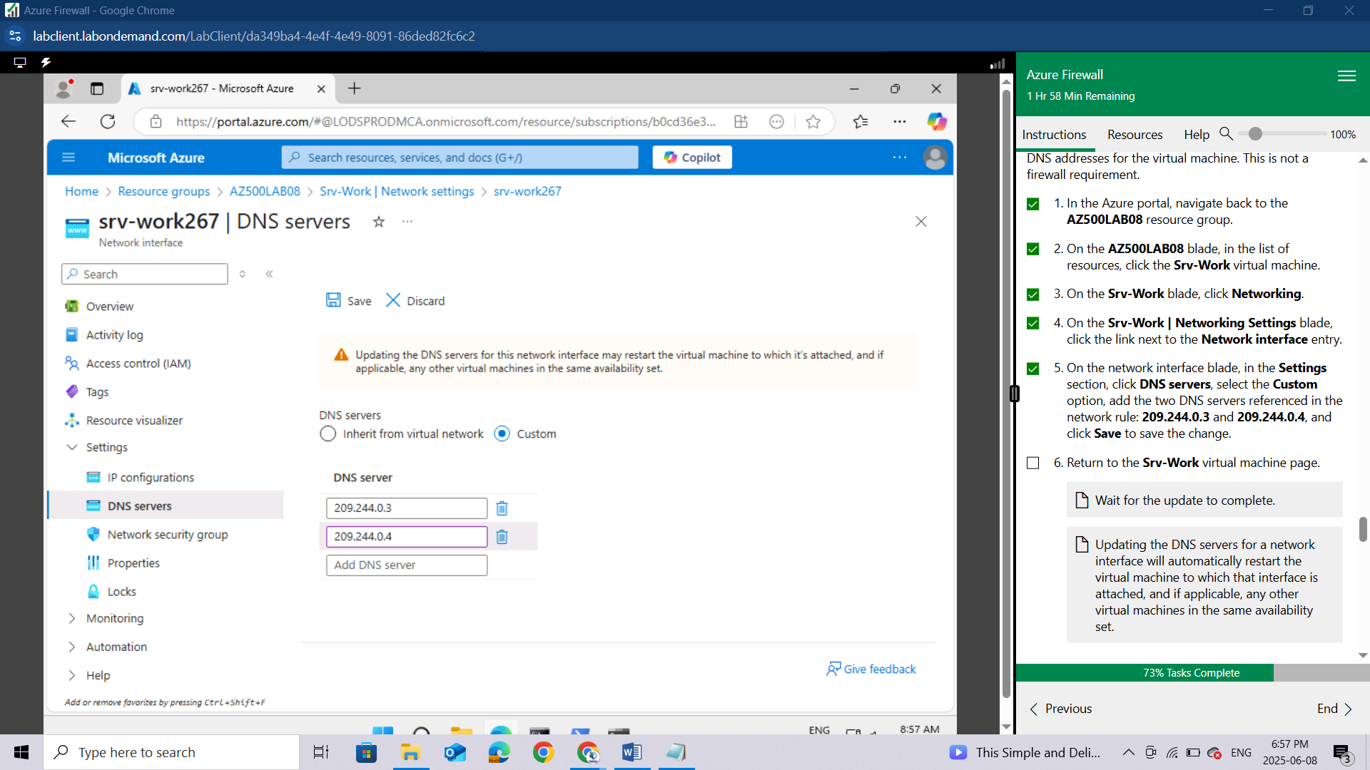

Return to the **Srv-Work** virtual machine page.

*Wait for the update to complete.*

*Updating the DNS servers for a network interface will automatically restart the virtual machine to which that interface is attached, and if applicable, any other virtual machines in the same availability set.*

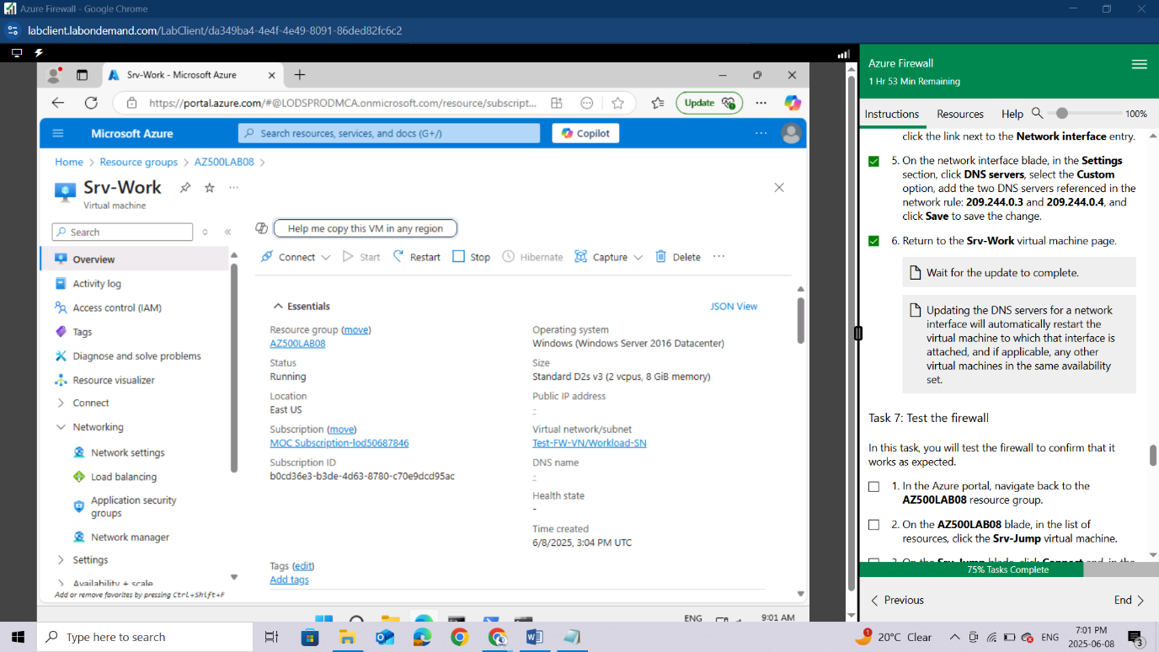

### Task 7: Test the firewall

In this task, you will test the firewall to confirm that it works as expected.

In the Azure portal, navigate back to the **AZ500LAB08** resource group.

On the **AZ500LAB08** blade, in the list of resources, click the **Srv-Jump** virtual machine.

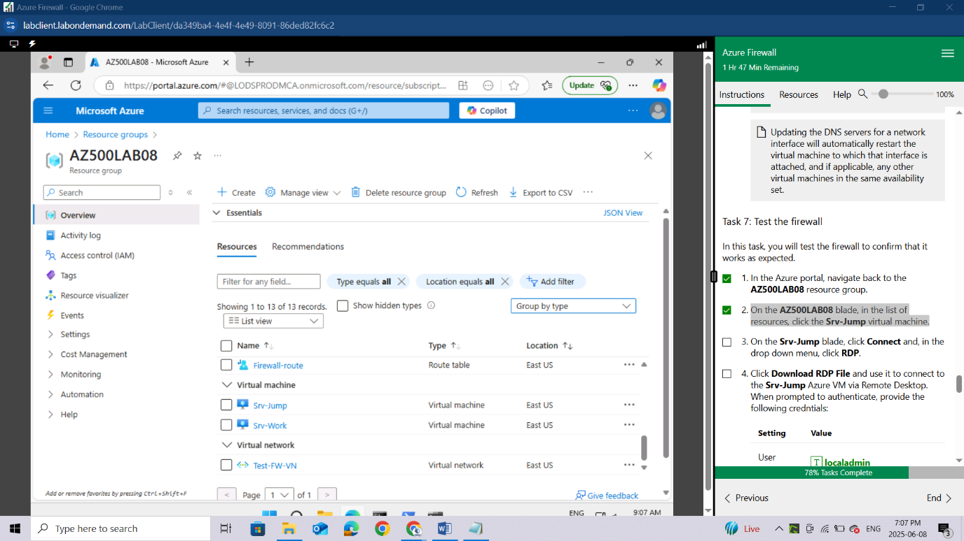

On the **Srv-Jump** blade, click **Connect** and, in the drop down menu, click **Connect**.

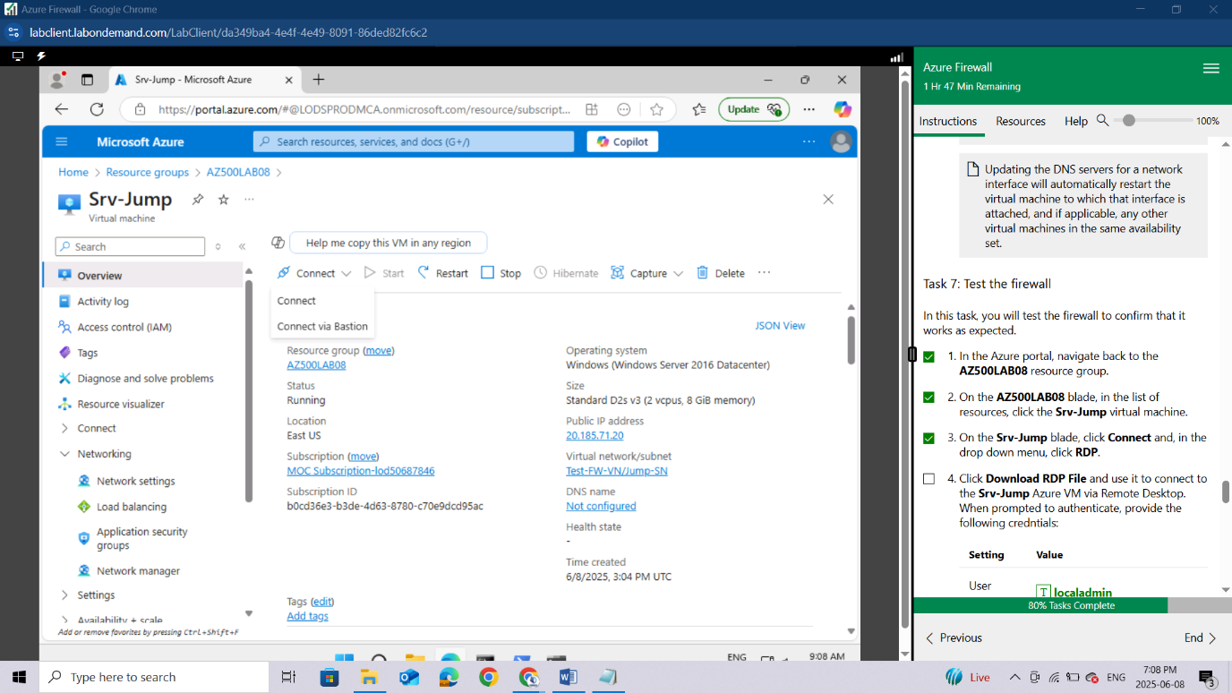

Click **Download RDP File** and use it to connect to the **Srv-Jump** Azure VM via Remote Desktop.

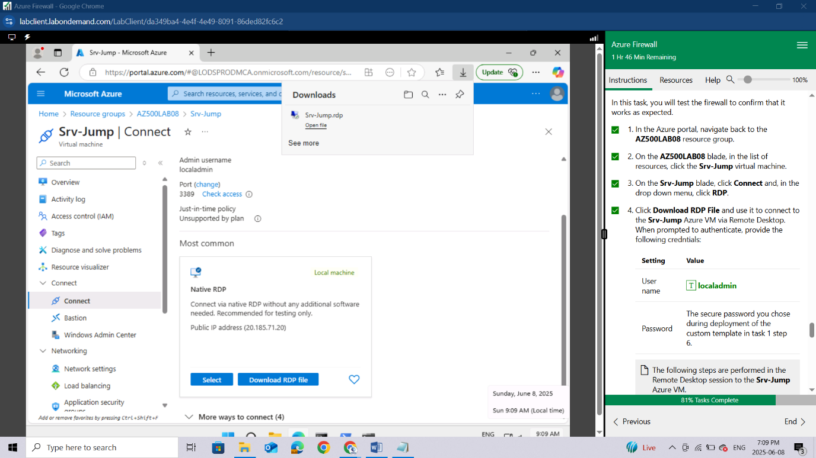

When prompted to authenticate, provide the following credntials:

| **Setting** | **Value** |
| --- | --- |
| User name | **localadmin** |
| Password | The secure password you chose during deployment of the custom template in task 1 step 6. |

*The following steps are performed in the Remote Desktop session to the****Srv-Jump****Azure VM.*

*You will connect to the****Srv-Work****virtual machine. This is being done so we can test the ability to access the bing.com website.*

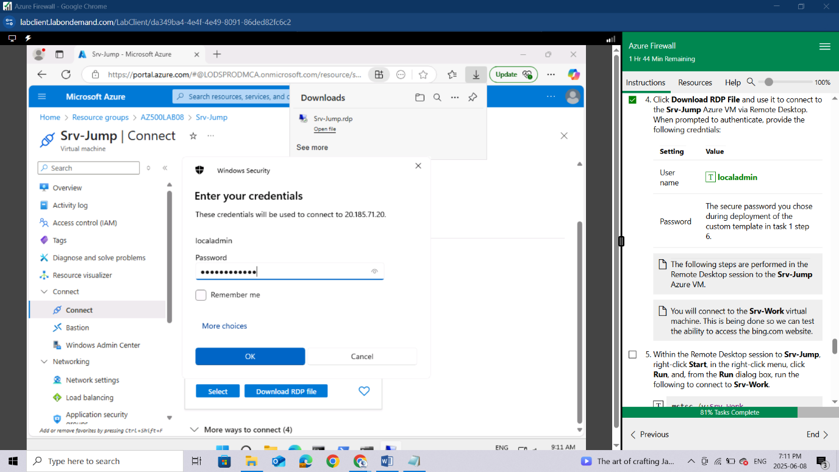

When prompted click **YES**

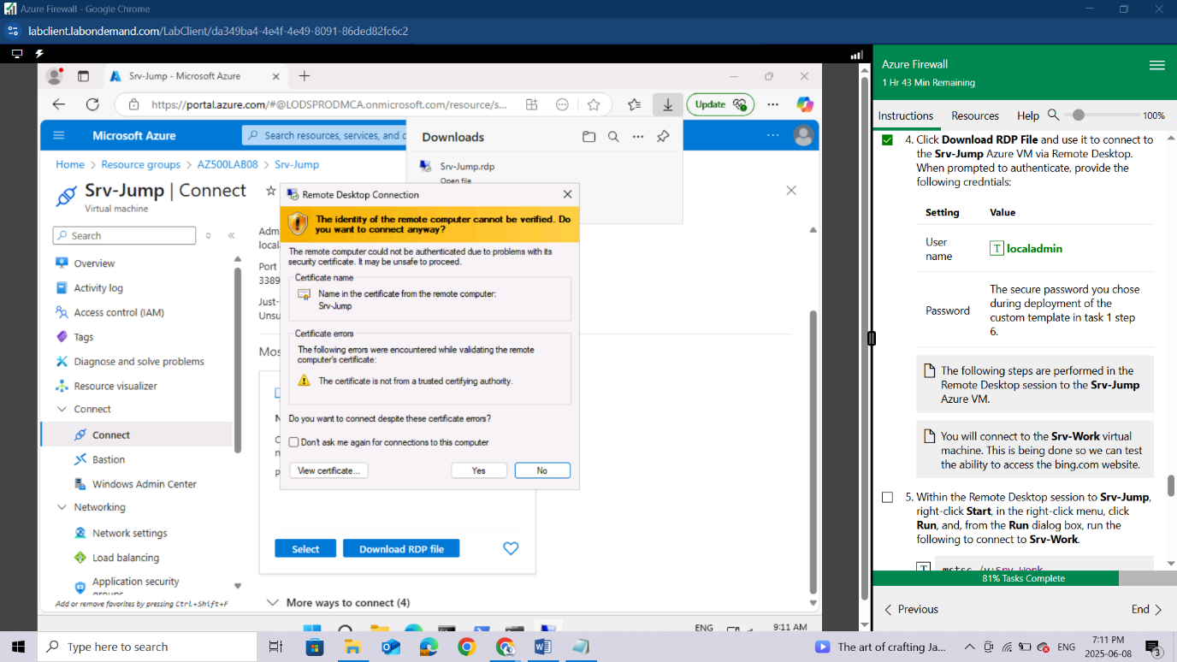

Within the Remote Desktop session to **Srv-Jump**, right-click **Start**, in the right-click menu, click **Run**,

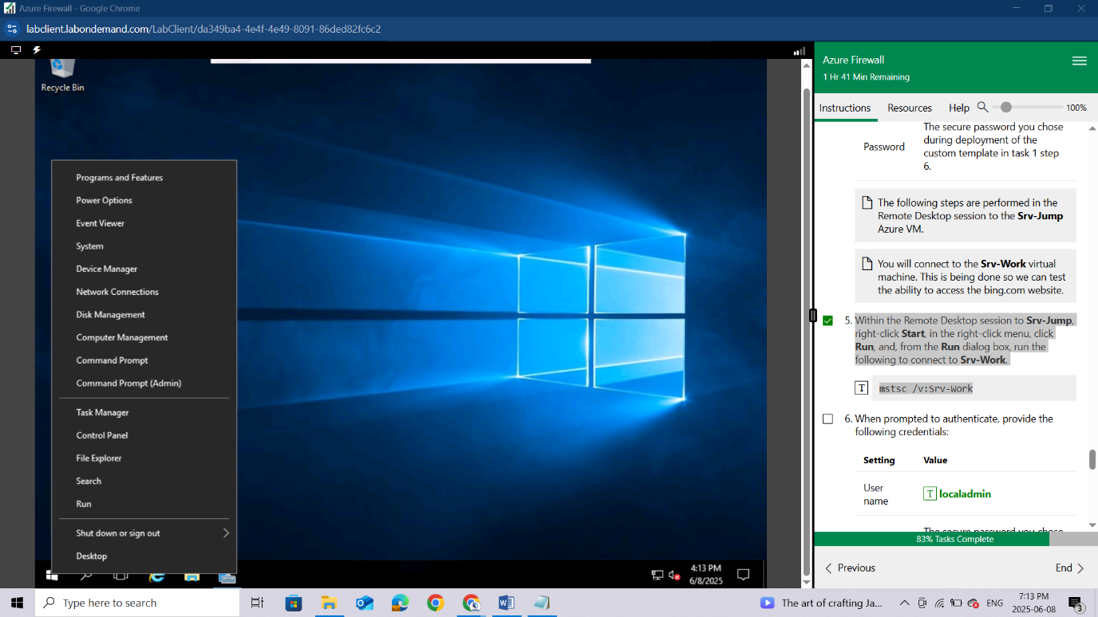

and, from the **Run** dialog box, run the following to connect to **Srv-Work**.

mstsc /v:Srv-Work

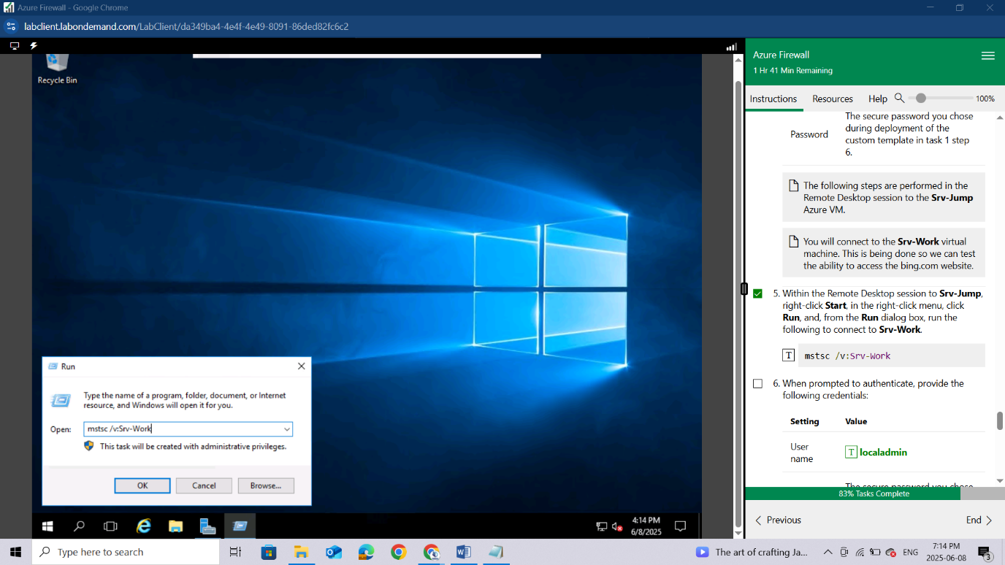

When prompted to authenticate, provide the following credentials:

| **Setting** | **Value** |
| --- | --- |
| User name | **localadmin** |
| Password | The secure password you chose during deployment of the custom template in task 1 step 6. |

*Wait for the Remote Desktop session to be established and the Server Manager interface to load.*

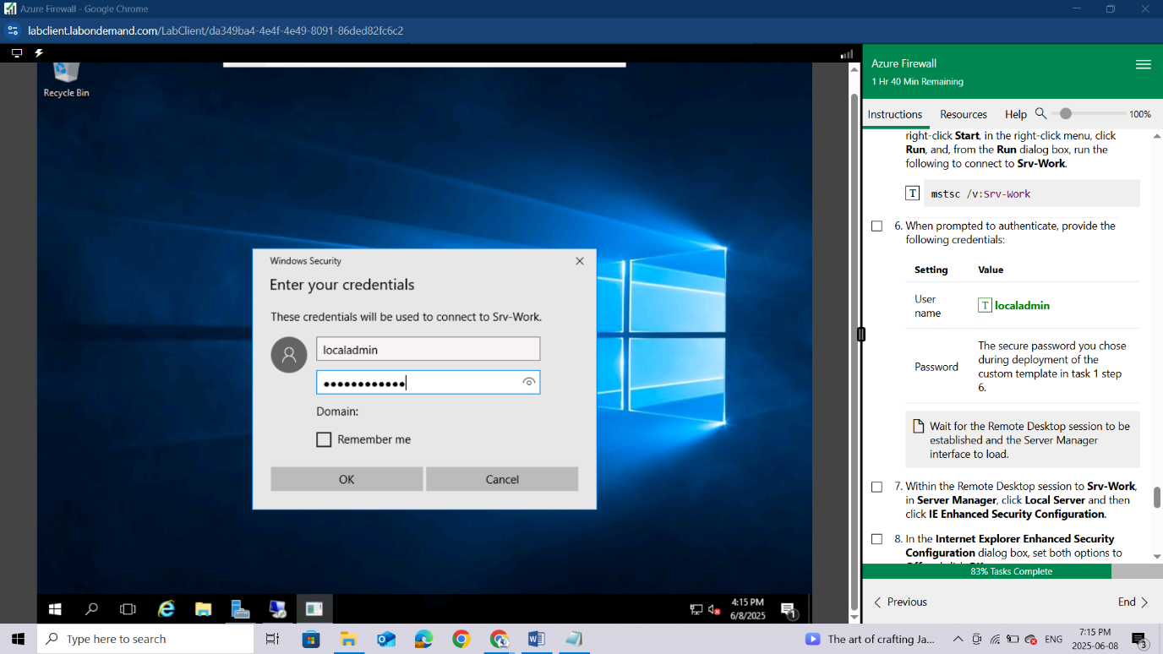

Within the Remote Desktop session to **Srv-Work**, in **Server Manager**, click **Local Server** and then click **IE Enhanced Security Configuration**.

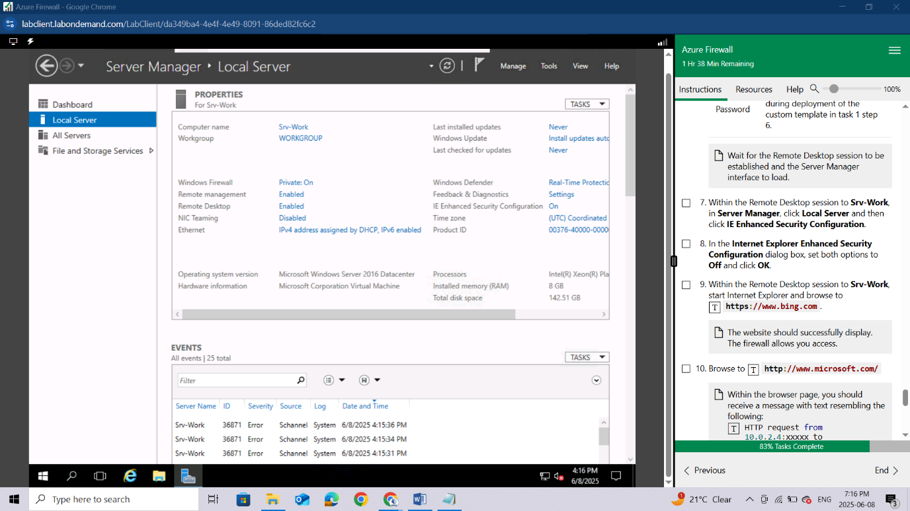

In the **Internet Explorer Enhanced Security Configuration** dialog box, set both options to **Off** and click **OK**.

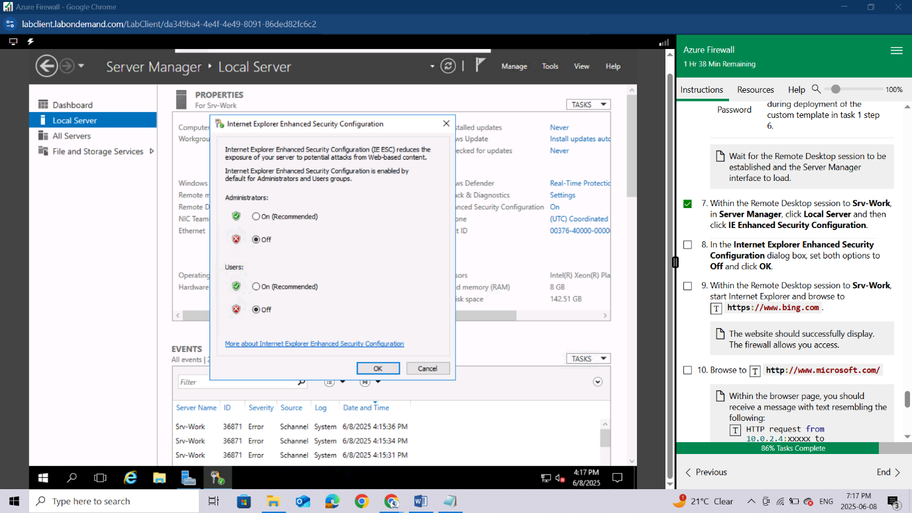

Within the Remote Desktop session to **Srv-Work**, start Internet Explorer and browse to [**https://www.bing.com**](https://www.bing.com).

*The website should successfully display. The firewall allows you access.*

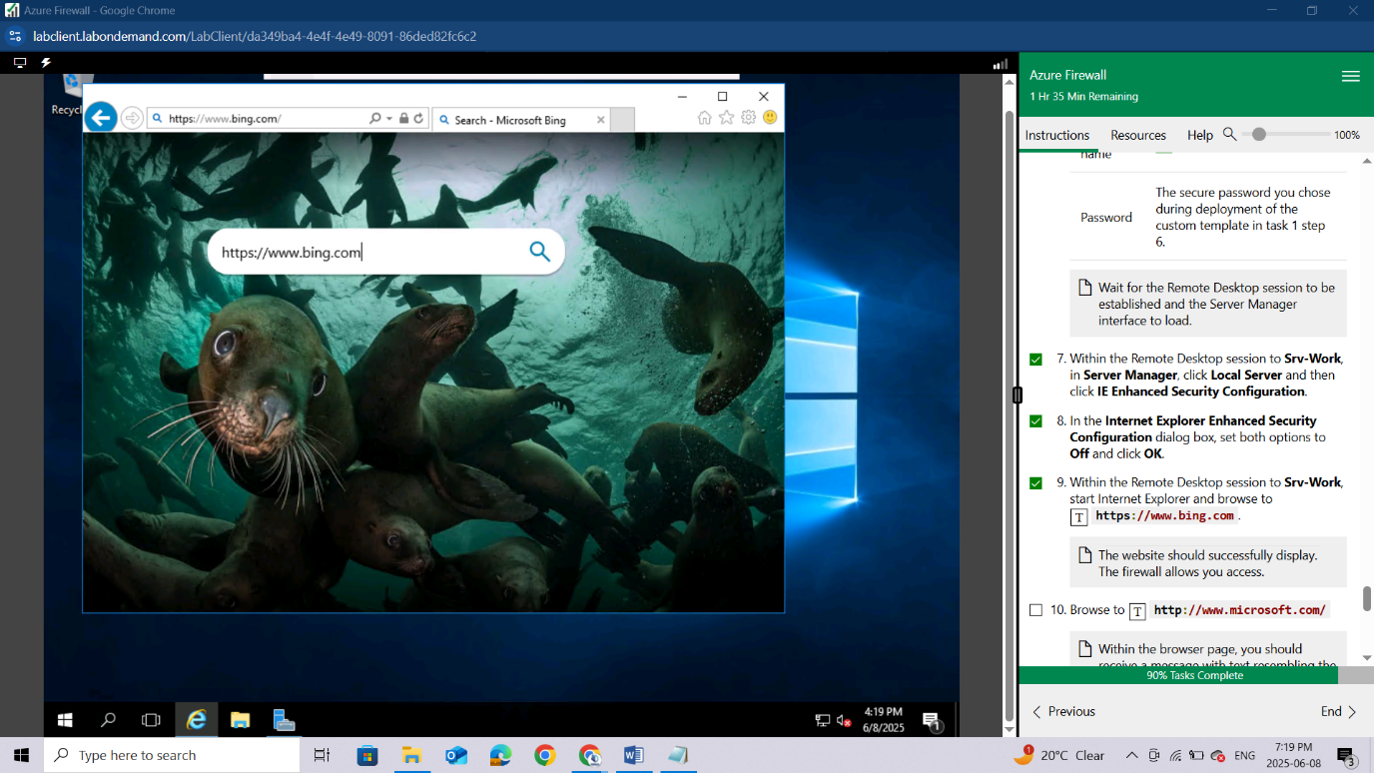

Browse to **http://www.microsoft.com/**

*Within the browser page, you should receive a message with text resembling the following: HTTP request from 10.0.2.4:xxxxx to microsoft.com:80. Action: Deny. No rule matched. Proceeding with default action. This is expected, since the firewall blocks access to this website.*

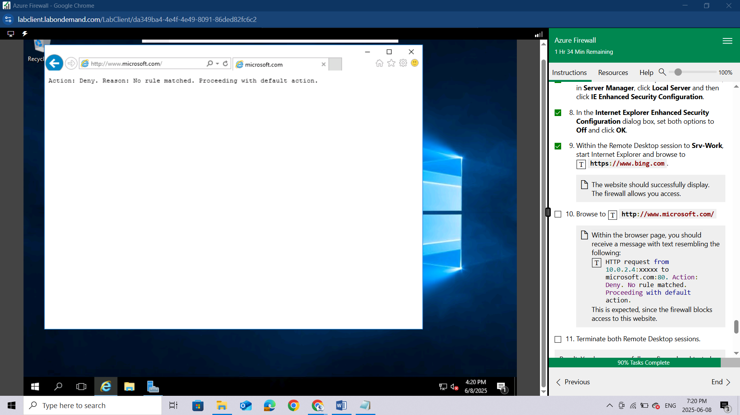

Terminate both Remote Desktop sessions.

*Result: You have successfully configured and tested the Azure Firewall.*

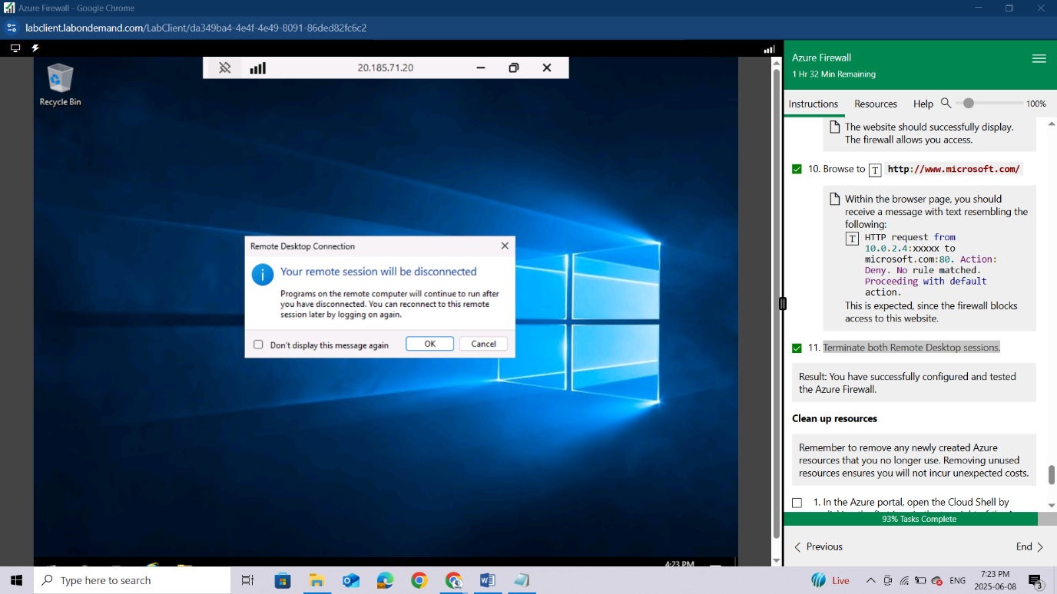

**Clean up resources**

*Remember to remove any newly created Azure resources that you no longer use. Removing unused resources ensures you will not incur unexpected costs.*

In the Azure portal, open the Cloud Shell by clicking the first icon in the top right of the Azure Portal.

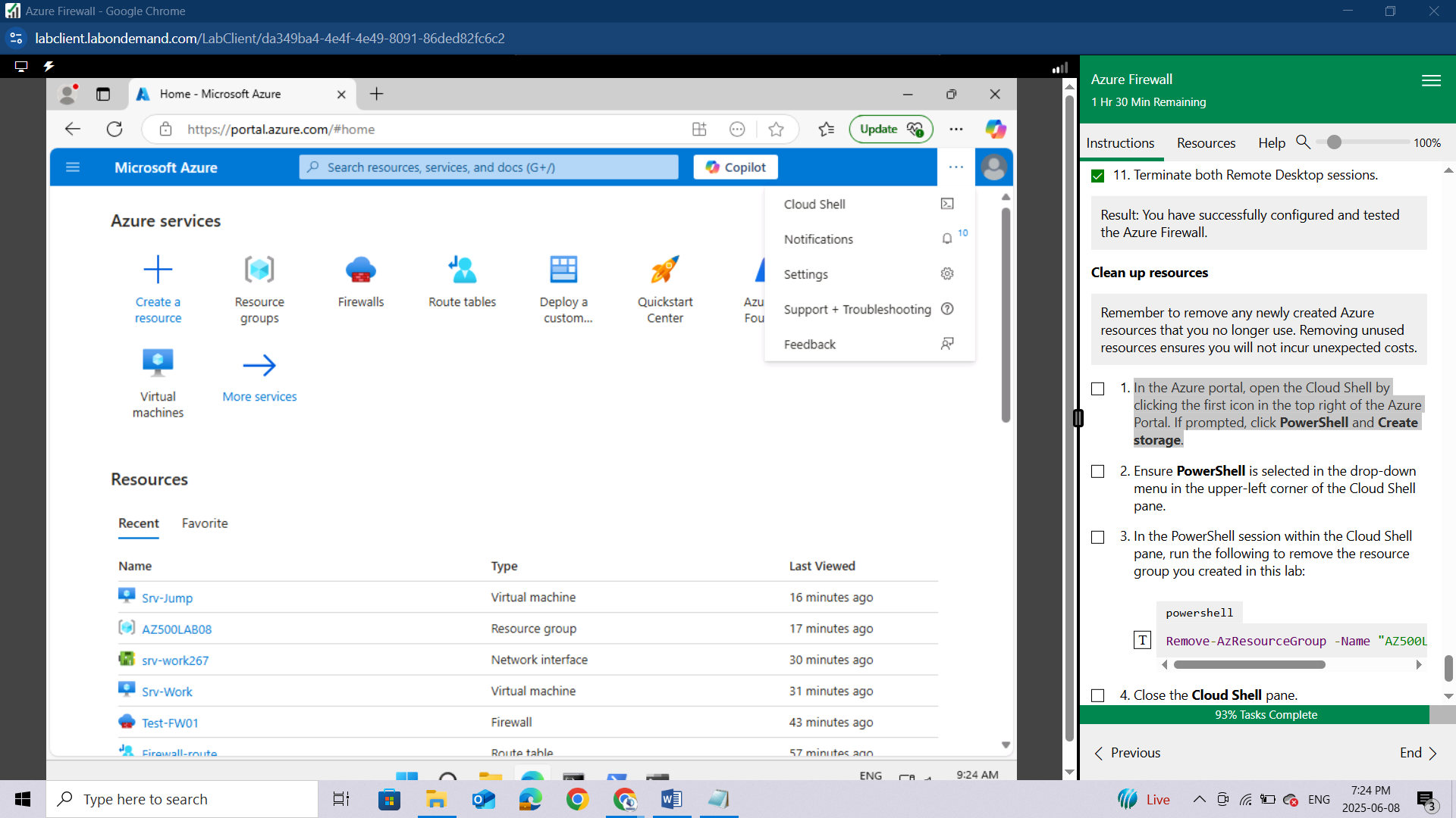

If prompted, click **PowerShell** and **Create storage**.

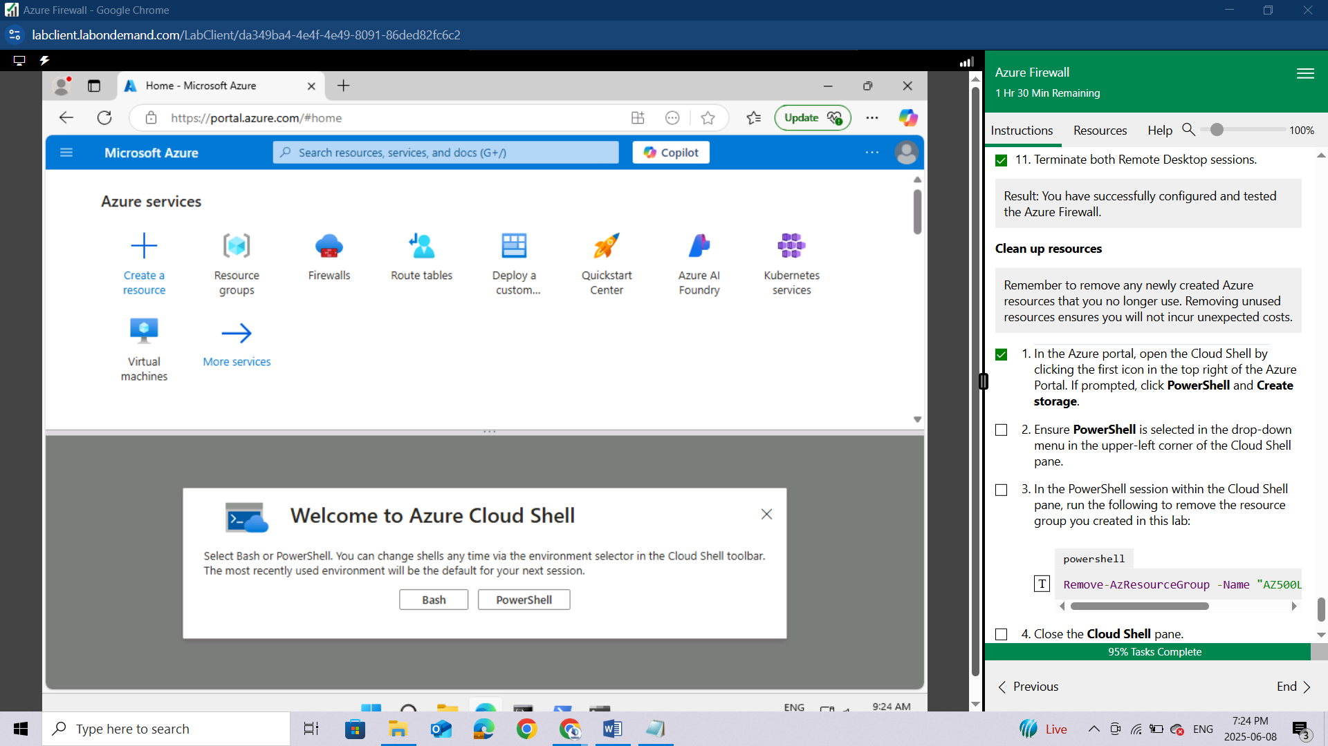

I will guide through the process of creating your storage

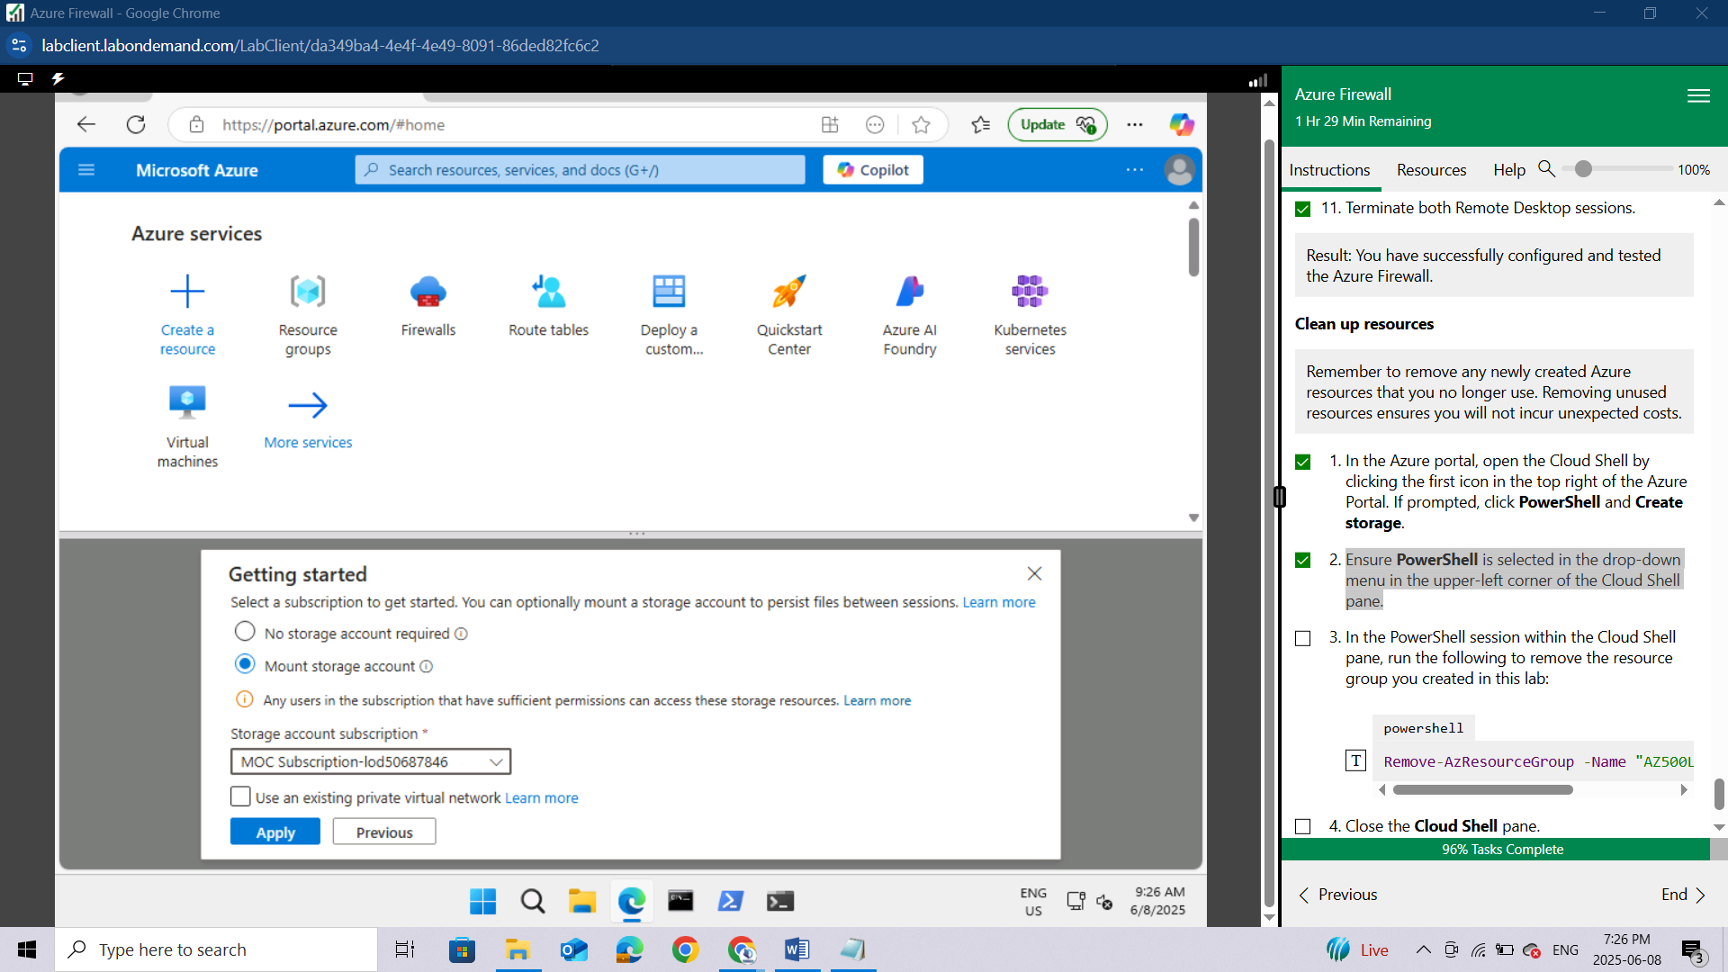

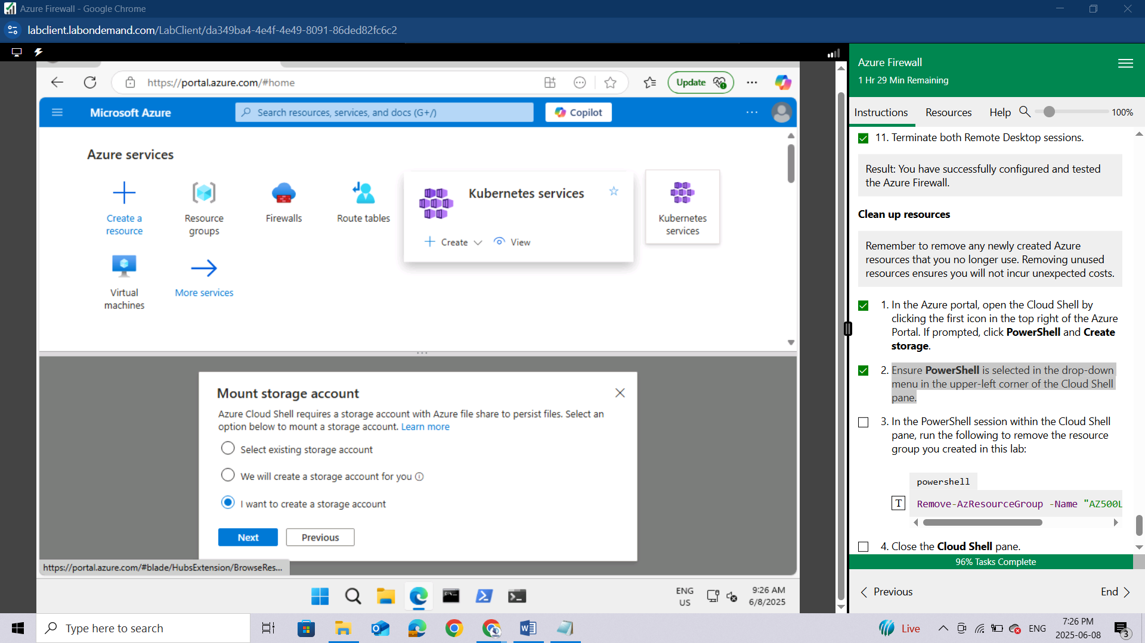

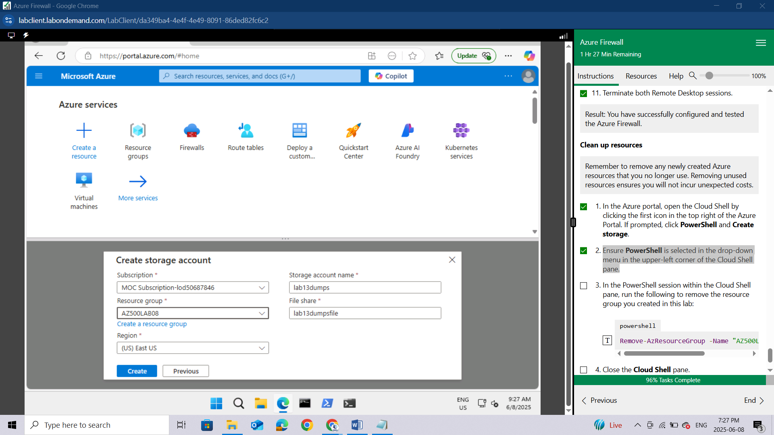

Ensure **PowerShell** is selected in the drop-down menu in the upper-left corner of the Cloud Shell pane.

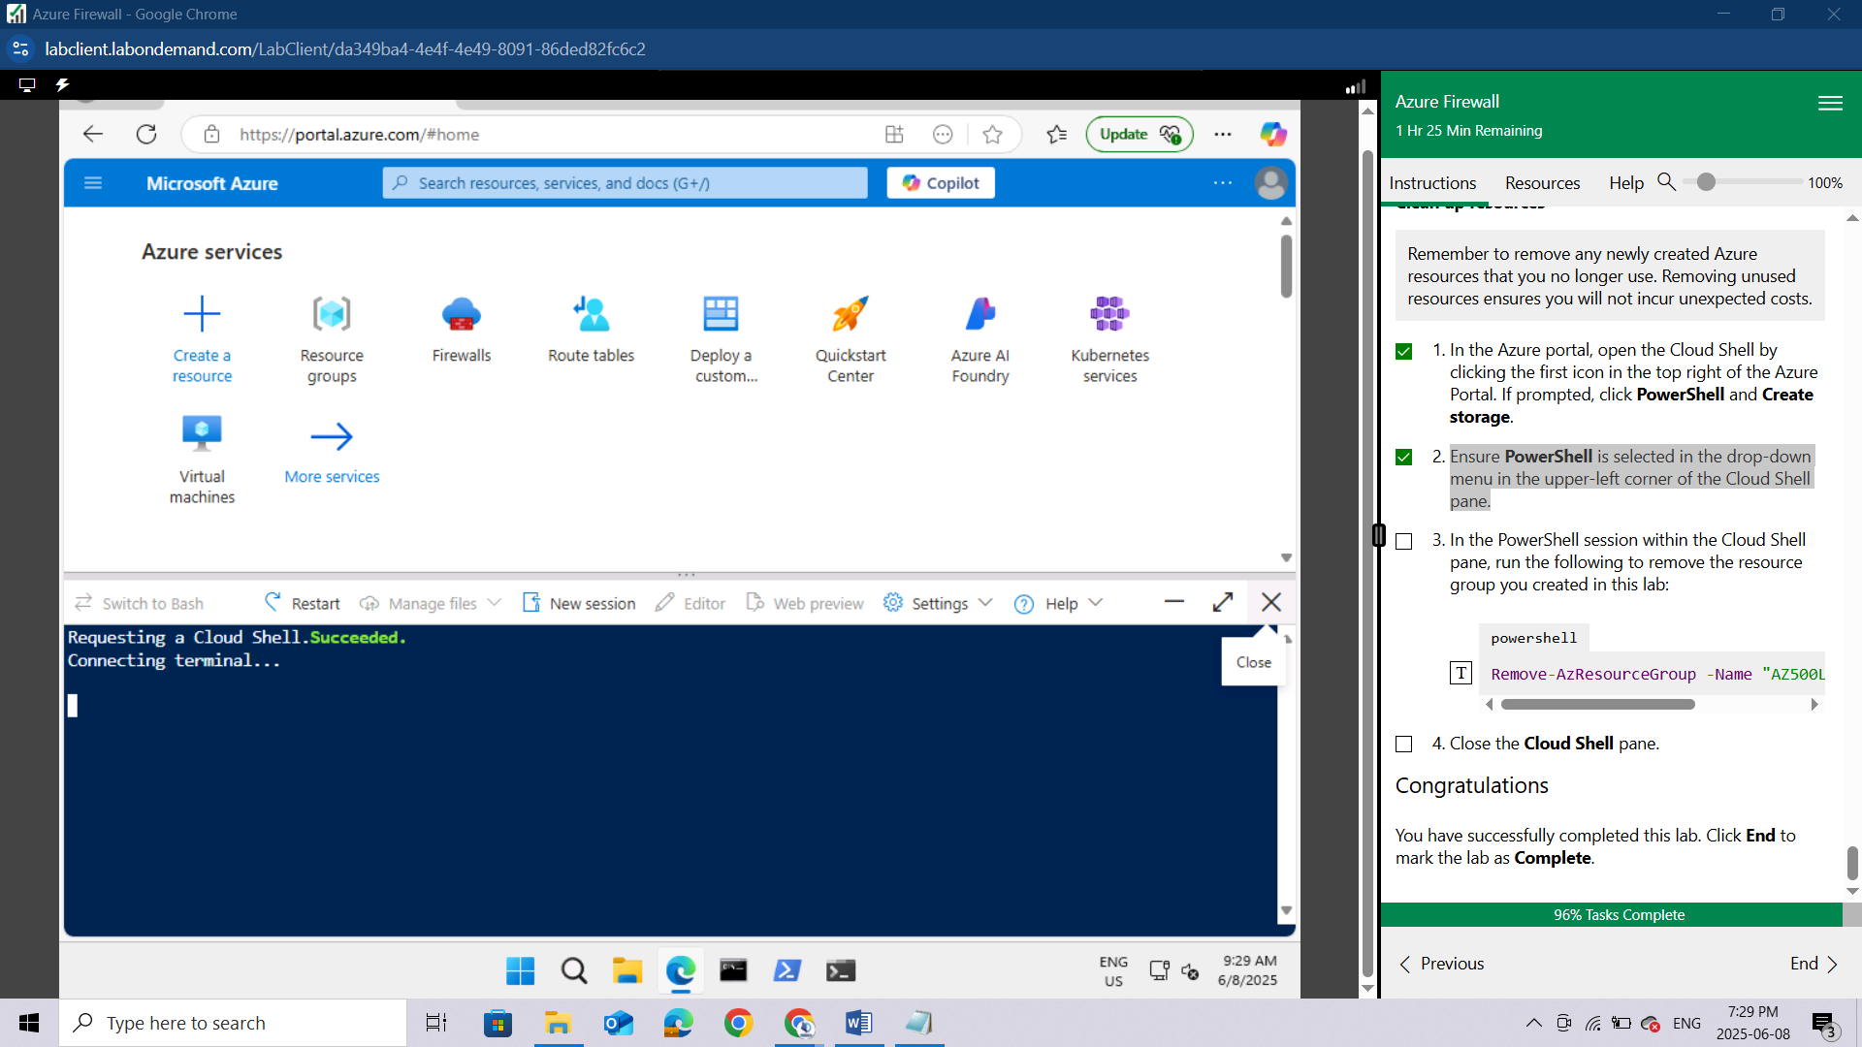

In the PowerShell session within the Cloud Shell pane, run the following to remove the resource group you created in this lab:

powershell

Remove-AzResourceGroup -Name "AZ500LAB08" -Force -AsJob

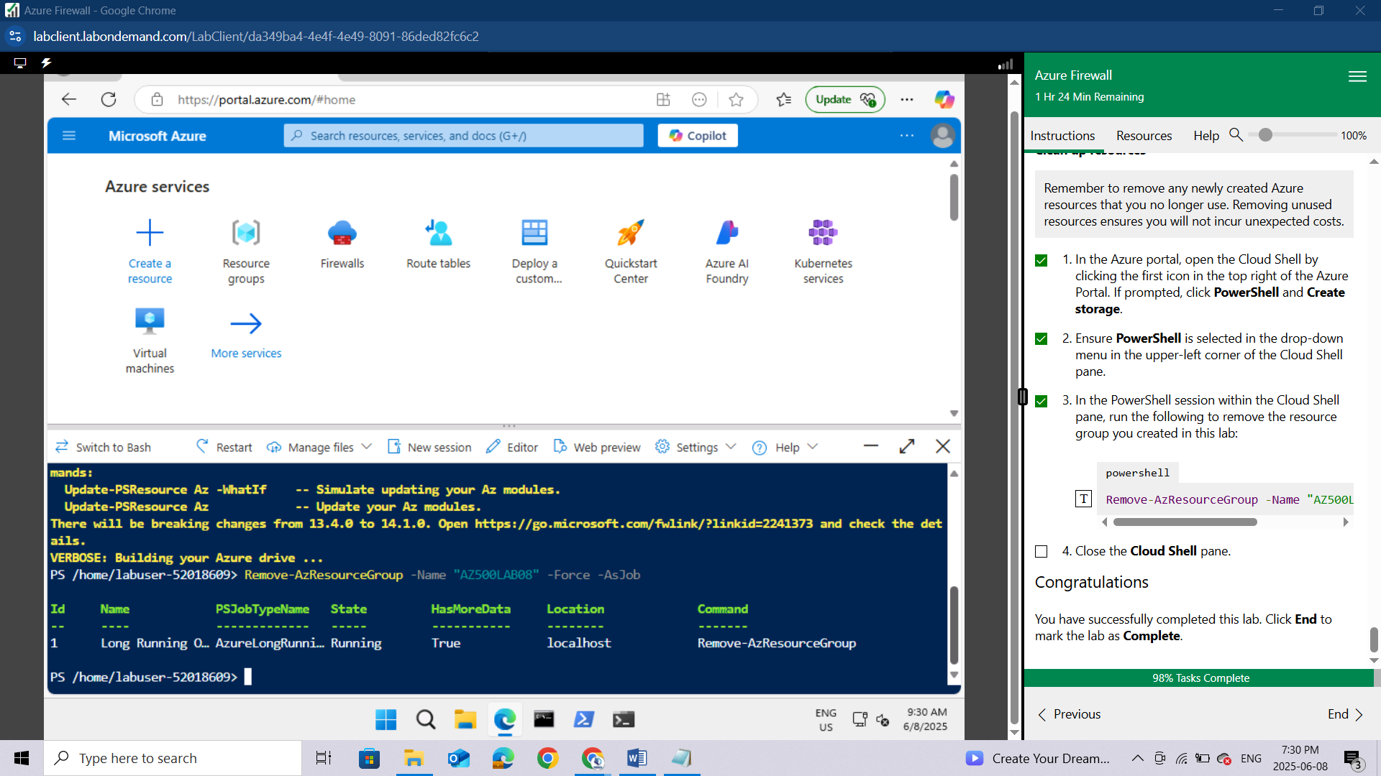

Close the **Cloud Shell** pane.

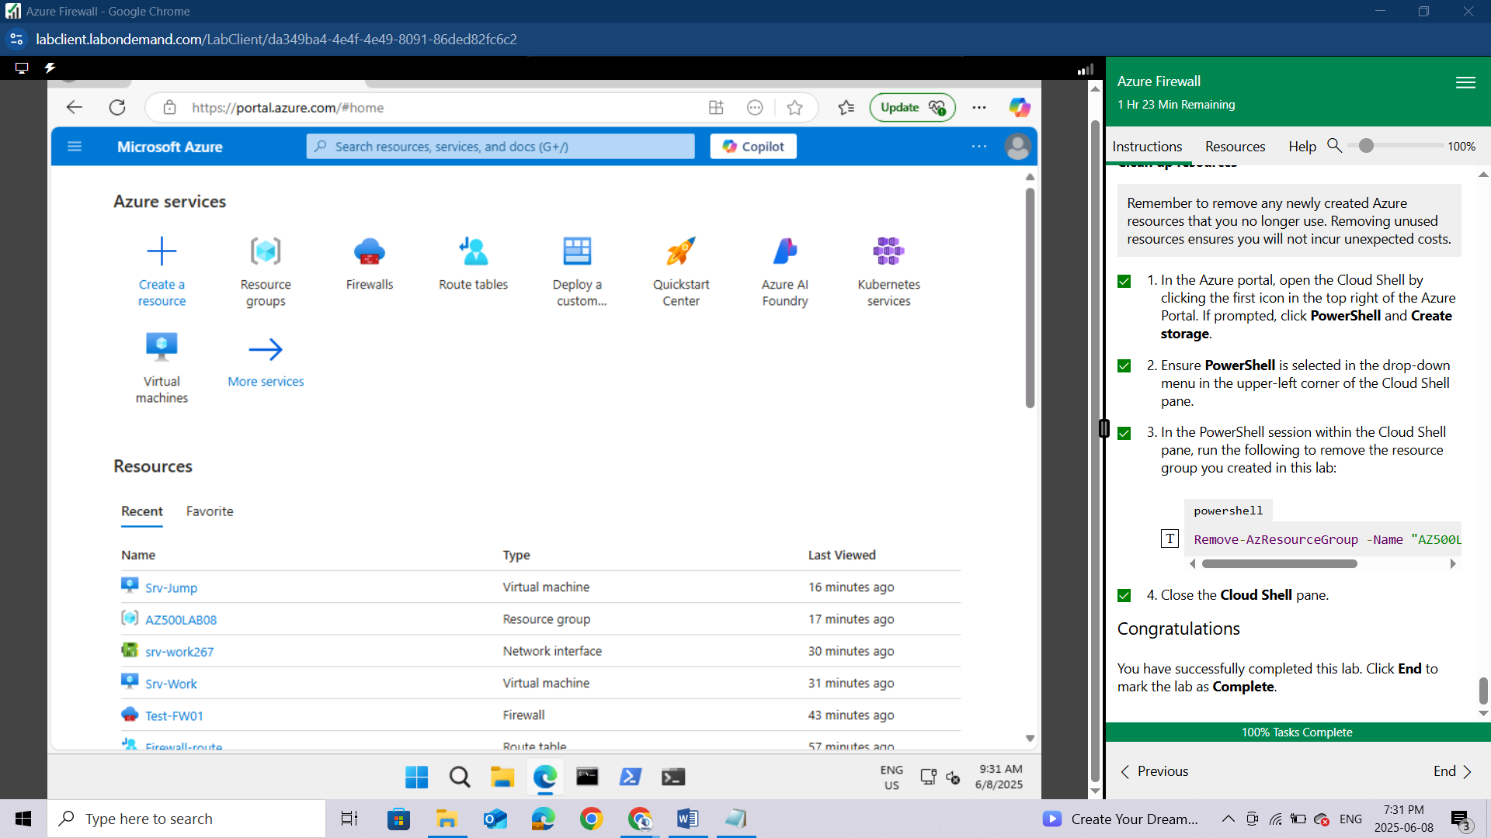

**Congratulations.** You have successfully completed this lab. Click **End** to mark the lab as **Complete**.

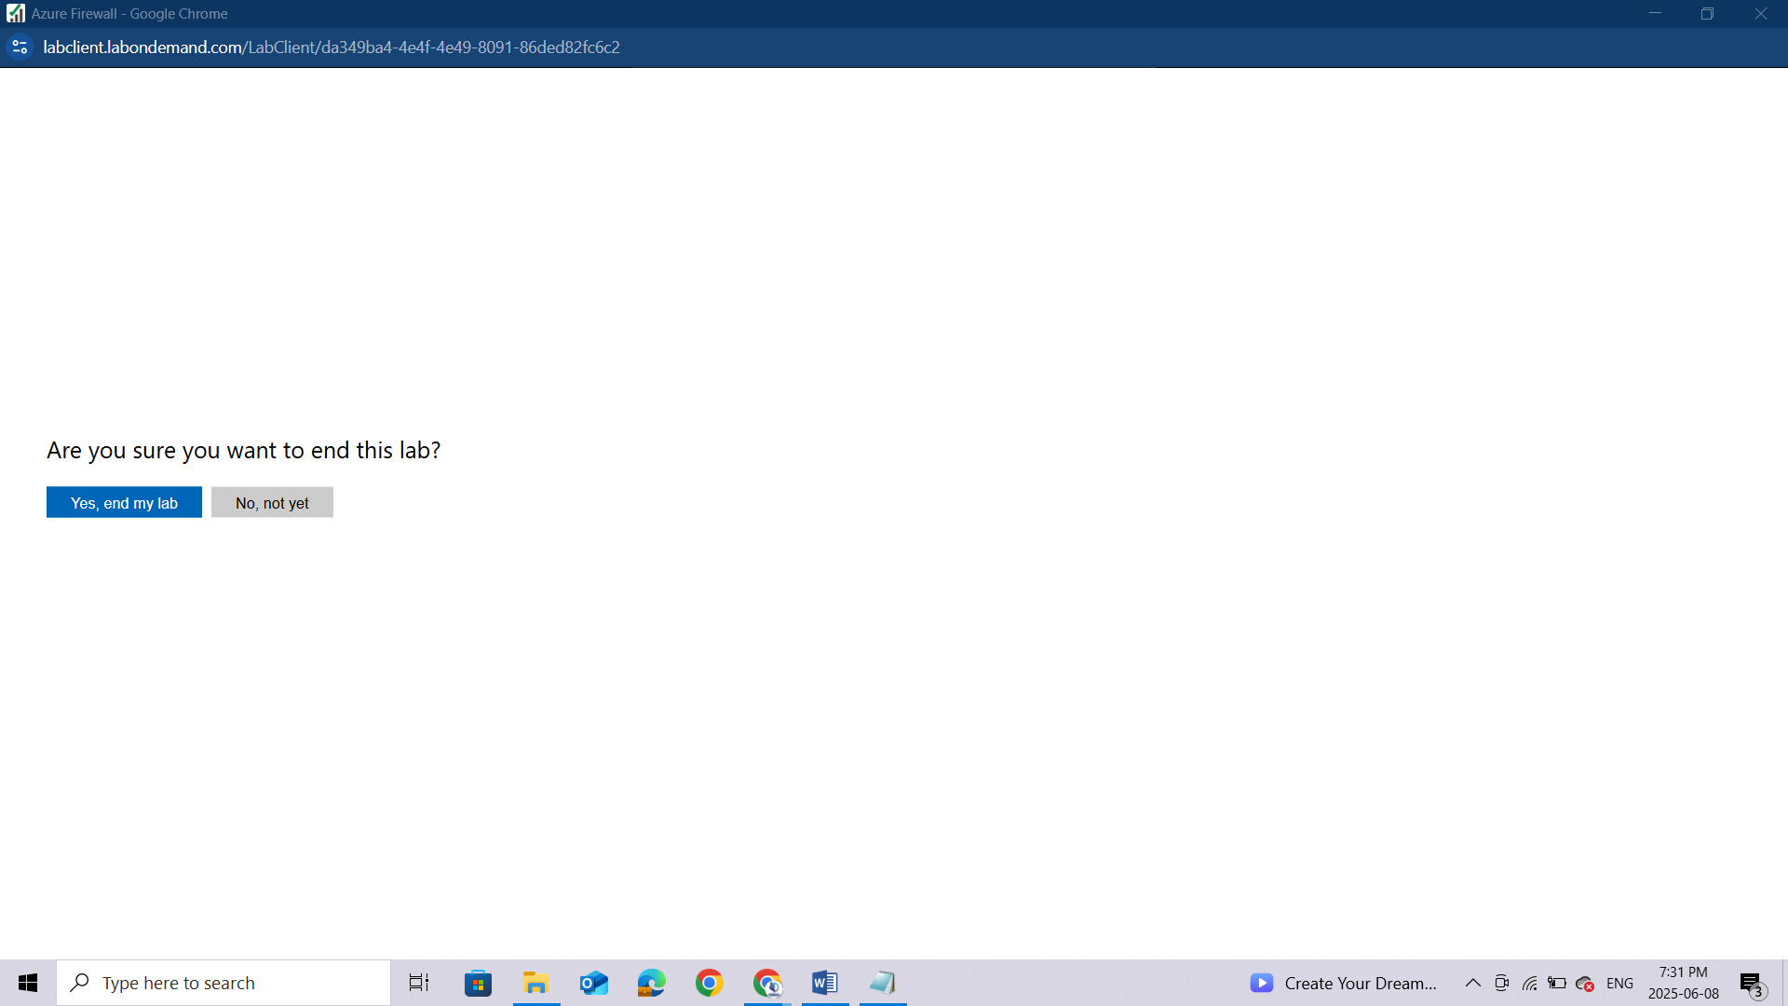

## Conclusion

Completing this lab provided valuable hands-on experience with **Azure Firewall**, reinforcing its role as a critical component in securing Azure network infrastructure. By deploying the firewall, configuring routing, setting up application and network rules, and customizing DNS settings, we gained a deeper understanding of how traffic can be effectively controlled and monitored within a cloud environment. Through testing, we validated the firewall’s ability to enforce security policies and restrict unauthorized access, demonstrating its effectiveness in protecting Azure resources. This lab not only enhanced our technical skills in managing Azure Firewall but also emphasized best practices in network security—essential for any organization operating in the cloud. Overall, the lab served as a practical and insightful step toward mastering Azure security technologies and preparing for real-world implementation scenarios.